THIS PAGE CAN BE DELETED FROM YOUR FINAL REPORT
(ALL text in blue can be deleted from your final submission, Text in red should be edited by you)
The following guidelines must be adhered to:

Writing Style
Your report should usually be written from a third person, observational perspective. Do not use the following terms:
Do use or model from the following examples which are written from an observational third person perspective:
"The researcher" or "the observer"  "It was observed that..."  "The data suggest..."  "The experiment revealed..."  "The results show..."  "One can infer that..."  "The study indicates..."  "The findings imply..."  "The evidence supports..."  "An analysis of the data" | "The procedure was executed as follows..."  "The measurements were taken..."  "The subjects/participants behaved in a certain way..."  "The test conditions were controlled..."  "The trends in the data"  "The observations were made by the team."  "The process was documented as..."  "The phenomenon was recorded."  "A statistical analysis was conducted."  "The data were collected and analysed."

Report Layout and Style
The following guidelines must be adhered to:
- All text will be black in the report unless in very exceptional circumstance.
- Main body text must be at least 11pt font using either Arial or Calibri font.
- Main body text will have 1.5 line spacing.
- Margins will be a minimum of 2 cm on each side.
- All pages will be numbered consecutively.
- Start each section on a new page.
- Figures must have captions and be numbered (e.g., Figure 1).
- Tables must have captions and be numbered (e.g., Table 1).
- Figures may be black and white, or colour.
Word Count
- There is a 8,000-word limit for the project. This is a maximum, not a target. Shorter is often better.
- All words in the main body, excluding words in figures and tables, will be included in the word count.
- Consider what can be removed from the main body and placed in an appendix to reduce the word count as not every detail may be necessary in the main document.
Copyright and Intellectual Property Rights (IPR)
Your report should be written considering that it will be within the public domain. Normally, you retain copyright over your written work and Intellectual Property Rights (IPR) over any technical work. There are rare situations where this might not be as simple, for example when working with a company, external client, or on a larger university project. There are strategies you can utilise:
- You can inform your supervisory team that the project cannot be made available to other students undertaking an MSc Project.
- You can provide a shortened report for sharing that does not contain the protected information.
- You can assign IPR to the external collaborator, although you should take great care when doing so. It is best to speak to your supervisor.
- Non-disclosure agreements can be made between the external collaborator and the supervision team.

Bayesian Flight Risk and Efficiency Optimiser:

An AI Approach to Safer and Greener Aviation

By
Osman Ebrahim

Submitted to
The University of Roehampton

In partial fulfilment of the requirements
for the degree of
BACHELOR OF SCIENCE IN COMPUTER SCIENCE

Declaration

I hereby certify that this report constitutes my own work, that where the language of others is used, quotation marks so indicate, and that appropriate credit is given where I have used the language, ideas, expressions, or writings of others.

I declare that this report describes the original work that has not been previously presented for the award of any other degree of any other institution.
Signed: Osman
Osman Ebrahim
Date: 11/01/2026

Acknowledgements
The researcher would like to express sincere gratitude to Dr Arturo Araujo, project supervisor, whose guidance, encouragement, and intellectual generosity have been invaluable throughout this work. It was Dr Araujo who first recognised the potential of an earlier essay on probabilistic aviation safety and encouraged its development into this Final Year Project — a recommendation that directly shaped the direction and ambition of this dissertation. His consistent support, from the earliest stages of university through to the submission of this report, is deeply appreciated.

Sincere thanks are also extended to Ogechukwu Okonor and Wei Li, whose support, encouragement, and generosity throughout the researcher's university journey have been a constant source of motivation. Their contribution to the researcher's academic development extends well beyond this project and has been greatly valued.

This project is dedicated to everyone who believed in its potential before it was fully realised.

Abstract
Aviation safety and environmental sustainability are typically analysed as separate domains within the research literature. The evidence suggests a clear gap in integrated approaches capable of simultaneously estimating accident probability and carbon emissions within a single probabilistic framework. This project addresses that gap by developing a Bayesian aviation decision-support system that unifies risk assessment and emissions modelling through a single inference pass.

The system is implemented as an interactive Streamlit web application trained on 88,000 real accident records from the NTSB Aviation Accident Database [38]. A Naive Bayes classifier — constructed from first principles using log-posterior computation and Laplace smoothing — estimates flight accident probability across three risk classes (Low, Medium, High). The data indicate that risk and fuel consumption are directly coupled: higher-risk operational states incur additional fuel burn through holding patterns, diversions, and emergency procedures. The unified model therefore applies Bayesian-weighted overhead factors to derive an expected CO₂ estimate from the same posterior probabilities used for risk classification, expressed as: CO₂_expected = Σ P(class|X) × base_CO₂ × overhead(class). Emissions factors are sourced from the ICAO/EASA Engine Emissions Databank v31 [39], covering 28 commercial aircraft variants.

The application incorporates real-time flight data via the AviationStack API [40], enabling users to enter a flight number and have risk analysis parameters automatically populated from live flight data. Route planning functionality integrates EASA Conflict Zone Information Bulletins [41], reflecting the February 2026 Middle East airspace closures affecting Iran, Iraq, Syria, Israel, and Kuwait. A direction-aware, ray-cast-verified conflict avoidance algorithm generates safe routing corridors across 777 airports in 200 countries. OpenSky Network flight records [42] are used for cross-reference validation of route statistics.

The findings demonstrate that Bayesian inference provides a transparent, interpretable foundation for integrated aviation decision-support. The study indicates that the unified model successfully estimates both accident probability and expected CO₂ in a single computation, meeting the primary research aim. The results show that all three evaluation scenarios — safe, moderate, and high-risk — produce correct risk classifications and plausible emissions estimates consistent with EASA benchmarks. The evidence supports the conclusion that probabilistic AI methods, when built with interpretability and transparency as primary design constraints, represent a viable and academically rigorous approach to safety-critical decision support in aviation.

Ethical and professional considerations are addressed throughout, with explicit reference to the EU AI Act (2024) [43], DO-178C software certification standards [44], GDPR data minimisation principles [45], and the BCS Code of Conduct [46]. The system is presented as an academic prototype and does not claim operational certification. All limitations — including geographic bias in the NTSB training data and the exclusion of non-CO₂ warming effects — are explicitly documented.
Table of Contents
1. Introduction 11
Problem Statement and Research question 11
Aims 12
Objectives 12
2. Background and Context 13
Background 13
Context 13
Summary of relevant published work (Literature review) 14
2.3.1 Aviation Safety and Accident Risk Modelling 14
2.3.2 Bayesian Theory and Probabilistic Inference 15
2.3.3 Bayesian Applications in Aviation Safety 15
2.3.4 Environmental Impact of Aviation and CO₂ Emissions 16
2.3.5 Integrating Safety and Sustainability through Bayesian AI 16
2.3.6 Summary and Identified Research Gap 17
Competitor Analysis/ Related work 17
3. Tools and Methods 19
3.1 Rationale for the technical tools selected 19
3.2 Rationale for the research methods used 21
3.3 Rationale for Project management tools and Product lifecycle used 22
Data Sources and Legal Compliance 23
Ethical Considerations in Aviation AI 23
Environmental Responsibility 24
Professional Standards 25
4. Requirements/Specifications 26
4.1 Personas 26
4.2 User Journey 27
4.3 Use Case Descriptions 27
4.4 Wireframe Descriptions 27
4.5 Functional Requirements 28
5. Solution design 28
Rationale for Research Methods Used 28
5.1 Choice of Bayesian Probabilistic Modelling 28
5.2 Unified Emissions Integration 29
5.3 Simulation-Based Evaluation 29
5.4 Development Methodology 30
5.5 Project Phases and Milestones 30
5.6 Time Management 31
5.7 Version Control 32
5.8 Risk Management 32
7. Solution implementation 33
7.1 Sprint 1 — Data Pipeline and Feature Engineering Weeks 1–3 33
7.2 Sprint 2 — Unified Bayesian Model Weeks 4–6 34
7.3 Sprint 3 — Dashboard and Pages Weeks 7–9 35
7.4 Sprint 4 — Conflict Zone Routing Weeks 10–12 35
7.5 Sprint 5 — Airport Expansion, Fuel Efficiency, and Finalisation | Weeks 13–15 36
8. Solution testing/ evaluation 36
8.1 Model Correctness — Risk Classification 37
8.2 Model Correctness — Unified Emissions 37
8.3 Routing Verification 38
8.4 Usability Assessment 39
8.5 Strengths 39
8.6 Limitations 40
9. Discussion 40
10. Conclusion 41
Summary 42
Recommendations for further work 42
Reflection 42
11. References 44
12. Appendices 49
Risk register 56
Appendix L - Entity Relationship Diagram (ERD) 63
Appendix M- Network / System Context Diagram 65

List of figures

List of Tables

Introduction
Aviation is a safety-critical industry in which operational decisions must be made under conditions of significant uncertainty. Despite major advances in aircraft engineering, regulatory oversight, and pilot training, risks associated with mechanical failure, adverse weather conditions, human performance, and system complexity remain unavoidable. It has been observed that traditional deterministic approaches often struggle to represent uncertainty explicitly, limiting their effectiveness in predicting and mitigating rare but high-impact events. As a result, probabilistic reasoning methods are increasingly being explored to enhance aviation safety analysis [17].

At the same time, the aviation sector faces growing pressure to reduce its environmental impact. Commercial aviation contributes a notable proportion of global carbon dioxide emissions, particularly during fuel-intensive phases such as climb, holding, and route deviation. The evidence suggests that inefficiencies in flight planning and operational decision-making can lead to unnecessary fuel consumption, thereby increasing emissions [7]. Current industry tools typically address safety and environmental performance separately, despite both being influenced by similar operational factors. This separation limits the ability to evaluate the real-world trade-offs that exist between risk mitigation and carbon output.

Bayesian inference offers a structured probabilistic framework for reasoning under uncertainty by updating prior beliefs as new evidence becomes available. An analysis of existing research indicates that Bayesian methods have been successfully applied to accident modelling, fault diagnosis, and risk assessment within aviation [17]. However, the integration of Bayesian approaches to jointly consider flight safety and CO₂ emissions remains under-explored. This project is motivated by the need to investigate whether Bayesian theory can support safer and more sustainable aviation decision-making within a unified analytical framework.

Problem Statement and Research question
The problem addressed in this study is the lack of integrated analytical approaches that simultaneously assess aviation safety risks and environmental impact under uncertainty. Airline operators, air-traffic management systems, and regulatory bodies are affected by this limitation, as decisions relating to routing, weather avoidance, and operational constraints often involve trade-offs between safety and fuel efficiency. It is important to address this issue because even small inefficiencies, when scaled across the global aviation network, can result in increased accident risk exposure and significant cumulative CO₂ emissions.

Research Question
How can Bayesian inference be applied to aviation decision-making to improve flight safety while reducing CO₂ emissions?

Aims
- To examine how Bayesian inference can be used to model uncertainty in aviation safety-critical decision-making.
- To investigate the relationship between probabilistic risk assessment and CO₂ emissions in flight operations.
- To evaluate the potential of Bayesian-based models to support safer and more environmentally sustainable aviation practices.

Objectives
- To review and critically evaluate existing literature on Bayesian methods applied to aviation safety and environmental analysis.
- To identify relevant variables influencing accident risk and fuel consumption within flight operations.
- To develop and implement a Bayesian model using appropriate computational tools to analyse safety and emissions outcomes.
- To assess the results of the model and interpret their implications for aviation decision-making.
- To document the development process, methodological choices, and project management activities in line with academic and supervisory requirements.

Background and Context

Background
Commercial aviation operates within a complex socio-technical system in which safety, efficiency, and environmental responsibility must be carefully balanced. Although air transport remains one of the safest modes of travel, accident investigations consistently demonstrate that incidents rarely arise from a single isolated cause. Instead, risk emerges through the interaction of multiple operational and human factors, including adverse weather conditions, aircraft age, maintenance quality, organisational pressure, and decision-making under uncertainty [18]. An analysis of historical accident data suggests that these influences are inherently probabilistic, meaning they vary across conditions and cannot be fully captured through purely deterministic approaches.

Alongside safety, the aviation industry is increasingly challenged by its environmental impact. Commercial flight operations contribute a notable proportion of global anthropogenic carbon dioxide emissions, primarily due to fuel burn during take-off, climb, and cruise phases [15]. Research indicates that operational inefficiencies such as extended routing, holding patterns, and conservative contingency planning may significantly increase fuel consumption and emissions output [16]. Despite the clear links between operational safety and environmental efficiency, current decision-support tools within aviation typically treat these domains separately. Bayesian inference provides a probabilistic framework well suited to addressing this need [17].

Context
The context of this study lies at the intersection of aviation safety engineering, environmental sustainability, and artificial intelligence. Regulatory organisations such as the International Civil Aviation Organization (ICAO) and national aviation authorities increasingly emphasise data-driven safety management systems and environmental performance monitoring. At the same time, advances in computational power and data availability have enabled the use of probabilistic AI techniques within safety-critical domains.
Within this context, Bayesian inference has gained attention due to its transparency, interpretability, and ability to incorporate expert knowledge alongside empirical data. Unlike black-box machine learning models, Bayesian systems allow probability distributions and uncertainty intervals to be examined directly, which is particularly important in safety-critical applications. The study is therefore positioned within a broader movement towards explainable and trustworthy AI in aviation.
The work is conducted within an academic setting and focuses on publicly available aviation data sources. The system developed is intended for analysis and decision-support rather than operational deployment. By investigating the combined modelling of accident probability and CO₂ emissions, the study addresses known limitations in existing tools and contributes to ongoing discussions surrounding sustainable aviation and ethical AI use.

Summary of relevant published work (Literature review)

2.3.1 Aviation Safety and Accident Risk Modelling
Aviation safety has historically been addressed through a combination of engineering standards, regulatory oversight, and post-incident investigation. Statistical analyses of aviation accidents indicate that failures rarely occur due to a single cause; instead, accidents emerge from complex interactions between technical, environmental, and human factors. Studies by Reason (1997) [53] and later safety system models emphasise the layered nature of defences in aviation systems, highlighting how latent conditions and active failures can align to produce catastrophic outcomes. Traditional accident risk assessment methods have relied heavily on deterministic or frequency-based statistical models. While effective for high-level trend analysis, such models struggle to represent uncertainty explicitly or adapt dynamically to new evidence — a fundamental limitation when applied to the rare but high-impact events that characterise aviation accidents.

More recent research has explored probabilistic risk assessment (PRA) techniques to address these limitations. Research conducted by Li et al. (2016) [56] demonstrates how Bayesian networks can be used to analyse runway excursion accidents, revealing how environmental and operational factors interact to increase risk. An important strength of Bayesian approaches identified in the literature is their ability to support scenario-based analysis: by adjusting input probabilities, analysts can explore how changes in operational procedures or environmental conditions influence accident likelihood — a capability that aligns closely with modern safety management systems emphasising proactive risk assessment.

2.3.2 Bayesian Theory and Probabilistic Inference
Bayesian theory offers a mathematical framework for reasoning under uncertainty through the use of probability distributions. Gelman et al. (2013) [54] provide a comprehensive foundation for Bayesian data analysis, demonstrating how probabilistic models can integrate prior knowledge with observed data. Within safety-critical systems, Bayesian inference has been shown to outperform classical statistical methods in scenarios where data is sparse or incomplete. The ability to incorporate expert judgement is especially valuable in aviation, where certain failure modes occur too infrequently to be captured adequately through historical data alone.

Bayesian networks represent one of the most widely used Bayesian tools in safety analysis. These graphical models encode probabilistic dependencies between variables, allowing complex systems to be modelled in an interpretable manner. Despite these advantages, the literature also identifies limitations: model construction can be complex and results are sensitive to the choice of prior distributions, though evidence suggests these challenges can be mitigated through careful model design [34].

2.3.3 Bayesian Applications in Aviation Safety
The application of Bayesian methods to aviation safety has gained increasing attention over the past two decades. Several studies have employed Bayesian networks to model accident causation by integrating factors such as weather conditions, aircraft system failures, and pilot decision-making. These models allow analysts to estimate the probability of an accident given a specific combination of conditions, providing a more flexible alternative to traditional safety assessments.
Research conducted by Li et al. (2016) demonstrates how Bayesian networks can be used to analyse runway excursion accidents, revealing how environmental and operational factors interact to increase risk. Similarly, studies focusing on mid-air collision risk and controlled flight into terrain have shown that Bayesian models can effectively capture dependencies between multiple risk variables.
An important strength of Bayesian approaches identified in the literature is their ability to support scenario-based analysis. By adjusting input probabilities, analysts can explore how changes in operational procedures or environmental conditions influence accident likelihood. This capability aligns closely with modern safety management systems, which emphasise proactive risk assessment rather than reactive investigation.
However, the majority of existing aviation safety studies focus exclusively on accident probability without considering environmental consequences. This separation reflects a broader trend within aviation research, where safety and sustainability are often treated as distinct domains.

2.3.4 Environmental Impact of Aviation and CO₂ Emissions
The environmental impact of aviation has become a significant research focus due to increasing global concern over climate change. Aircraft CO₂ emissions are primarily driven by fuel consumption, influenced by aircraft type, flight distance, routing efficiency, and operational decisions. Lee et al. (2021) [57] quantify the contribution of global aviation to anthropogenic climate forcing for 2000 to 2018, establishing that aviation accounts for a notable proportion of global emissions with an effective radiative forcing approximately 3.5 times larger than the CO₂-only figure when contrails and NOₓ effects are included. Research into aviation emissions has traditionally focused on fuel efficiency improvements through aircraft design and operational optimisation, using deterministic fuel burn calculations or regression-based emissions estimates. While effective for average estimates, these approaches do not adequately represent uncertainty or variability in operational conditions.

2.3.5 Integrating Safety and Sustainability through Bayesian AI
A growing body of interdisciplinary research argues for the integration of safety and environmental considerations within a unified analytical framework. However, an analysis of existing literature indicates that most Bayesian aviation studies focus on safety alone, while emissions research rarely incorporates probabilistic risk modelling. Several studies have highlighted that safety-driven operational decisions — such as conservative routing or extended holding patterns — can inadvertently increase fuel consumption and emissions, suggesting an inherent trade-off between safety margins and environmental performance. This gap presents the opportunity this project addresses: by extending Bayesian safety models to include emissions-related variables, it becomes possible to evaluate how operational decisions influence both accident probability and CO₂ output simultaneously, within a single transparent framework that aligns with the broader shift towards explainable artificial intelligence in safety-critical contexts [20] [21].

2.3.6 Summary and Identified Research Gap
The literature reviewed demonstrates that Bayesian theory is well established as a powerful tool for modelling uncertainty and supporting decision-making in complex systems. Its application to aviation safety has been shown to provide valuable insights into accident causation and risk assessment. Separately, extensive research exists on aviation CO₂ emissions and environmental sustainability.
However, the evidence indicates a clear gap in the integration of these two domains. Existing tools and studies typically treat safety and emissions independently, limiting their ability to capture trade-offs inherent in real-world aviation operations. Few studies attempt to model accident probability and environmental impact within a single probabilistic framework.
This project addresses this gap by investigating how Bayesian theory can be used to estimate both accident risk and CO₂ emissions simultaneously. The findings from this literature review directly inform the methodological approach of the study, supporting the use of Bayesian inference as a suitable foundation for developing an integrated safety and sustainability model [2].

Competitor Analysis/ Related work
Existing research and industrial tools addressing aviation safety and environmental impact tend to treat these two challenges as largely independent problems. Safety-focused studies commonly concentrate on accident causation, failure prediction, or human factors analysis, while emissions-focused tools typically estimate fuel burn and CO₂ output based on fixed operational parameters. This separation limits the ability to evaluate trade-offs between safety and sustainability in a unified decision-making framework.

Aviation Safety Modelling Approaches
A substantial body of literature has explored statistical and machine-learning techniques for aviation accident analysis. Traditional approaches include regression models and fault tree analysis, which identify correlations between risk factors such as weather conditions, aircraft age, and maintenance frequency. While these methods provide useful insights, they often rely on static assumptions and struggle to adapt dynamically to new information. Moreover, deterministic outputs can obscure underlying uncertainty, which is critical in safety-critical domains.
More recent studies have introduced probabilistic graphical models, including Bayesian networks, to represent causal relationships between contributing factors and accident outcomes. These models have demonstrated improved interpretability and robustness when dealing with sparse accident data. However, existing Bayesian safety models are typically designed for post-incident analysis or regulatory reporting rather than real-time decision support. Additionally, they rarely integrate environmental performance metrics such as fuel consumption or emissions impact.

CO₂ Emissions and Flight Efficiency Tools
Commercial and academic tools for aviation emissions estimation, such as flight CO₂ calculators and route efficiency models, focus primarily on fuel burn calculations derived from aircraft type, distance, and load factors. While these tools are effective for high-level reporting and passenger-facing applications, they generally assume optimal operating conditions and do not account for operational uncertainty or safety-related constraints. As a result, they provide limited insight into how risk mitigation strategies may influence environmental outcomes.
Several optimisation-based approaches have been proposed to reduce emissions through improved routing or altitude selection. However, these approaches often rely on deterministic optimisation techniques that do not explicitly model uncertainty or dynamically update predictions in response to changing conditions such as weather disruptions or traffic congestion [12].

Limitations of Existing Approaches
Across both safety and emissions domains, a key limitation of existing tools is the absence of a unified probabilistic framework capable of jointly modelling accident risk and environmental impact. Safety tools prioritise risk reduction without considering emissions consequences, while emissions tools optimise efficiency without accounting for safety uncertainty. Furthermore, black-box machine-learning approaches, although potentially accurate, often lack the transparency and explainability required in regulated aviation contexts [14].

Positioning of the Proposed System
The proposed project addresses these limitations by introducing a Bayesian decision-support model that integrates safety and emissions analysis within a single probabilistic framework. By continuously updating probability estimates as new evidence becomes available, the system supports dynamic assessment of both accident risk and CO₂ output. Unlike existing tools, the model explicitly represents uncertainty through probability distributions, enabling interpretable and ethically responsible decision support rather than prescriptive control.
This integrated approach differentiates the project from existing safety models and emissions calculators, positioning it as a novel contribution that aligns with modern aviation requirements for explainability, sustainability, and risk-aware decision-making.

Tools and Methods
This section describes how the project is undertaken, including the technical tools, research methodologies, project management approach, and the legal, ethical, and professional considerations that influence design decisions. The selected methods are justified with reference to the literature review and the safety-critical nature of aviation systems.

3.1 Rationale for the technical tools selected
The technical tools selected for this project were chosen to support probabilistic modelling, transparency, reproducibility, and iterative development — essential requirements in aviation-related research. The primary programming language used is Python, due to its widespread adoption in scientific computing, strong ecosystem of data analysis libraries, and extensive use in both academic research and industry applications [19] [37]. The project is developed using Visual Studio Code as the primary integrated development environment, selected for its lightweight performance, native Python debugging support, integrated terminal, and seamless Git version control integration [37]. The application is built as a Streamlit web application [36], a Python framework that enables the rapid construction of interactive, browser-based data science dashboards without requiring separate front-end development. This combination of VS Code and Streamlit supports iterative, test-driven development where model changes are immediately visible in the running application, facilitating rapid prototyping and continuous validation of outputs.

For data processing and numerical computation, Pandas is used to load, clean, and transform aviation datasets — including the 88,000-record NTSB AviationData.csv file — and NumPy supports array-level operations during feature engineering [19]. The Folium mapping library is used to render interactive great-circle route maps with real WGS-84 airport coordinates, overlaid with EASA conflict zone polygons derived from official Conflict Zone Information Bulletins [25].

Bayesian inference is implemented from first principles using Python's built-in math library, without reliance on probabilistic programming frameworks. The Naive Bayes classifier computes log-posterior probabilities using the formula log P(C|X) = log P(C) + Σ log P(xᵢ|C), with Laplace smoothing (α=1) applied to prevent zero-probability predictions on unseen feature combinations. This implementation choice was deliberate: building the model from scratch rather than using a library demonstrates a deeper understanding of the underlying mathematical principles and allows complete transparency over every computational step — a particularly important consideration in safety-critical domains where black-box outputs are inappropriate [20] [21]. The log-probability formulation avoids floating-point underflow that would occur when multiplying many small probabilities directly [35].

A further innovation is the unified emissions layer integrated directly into the Bayesian inference pass. Rather than computing risk and CO₂ emissions as separate independent outputs, the system weights the carbon estimate by the posterior risk probabilities: CO₂_expected = Σ P(class|X) × base_CO₂ × overhead(class). This reflects the real-world relationship between risk level and fuel consumption — higher-risk operations such as holding patterns, diversions, and emergency procedures incur measurable additional fuel burn. CO₂ base factors are derived from the ICAO/EASA Engine Emissions Databank v31 [24], the authoritative engine-level fuel consumption reference used across the European aviation regulatory framework. Route planning incorporates real airspace intelligence from EASA CZIBs (2026-03-R5) [25] [26], encoding 14 active conflict zone polygons into a ray-casting polygon detection algorithm. Safe avoidance routes are computed using a direction-aware multi-waypoint corridor system, verified against all conflict zone polygons at high resolution.

Alternative approaches were considered and rejected on principled grounds. Deep learning frameworks such as TensorFlow and PyTorch were evaluated but found unsuitable: they require substantially larger datasets, offer limited interpretability, and function as black-box models — characteristics incompatible with safety-critical aviation systems [21]. Probabilistic programming libraries such as PyMC introduce unnecessary sampling overhead for a model whose posterior can be computed analytically [34]. Commercial aviation risk tools were reviewed but not adopted due to their closed-source nature. Flight number lookup is implemented via the AviationStack REST API [27], providing real-time flight status, route information, and aircraft type data. All code is version-controlled using GitHub, enabling transparent tracking of development progress and evidence of professional software engineering practice in line with the BCS Code of Conduct [28].

3.2 Rationale for the research methods used
The research methodology adopted in this project is probabilistic modelling using Bayesian inference, supported by simulation and data-driven analysis. Bayesian methods have a well-established history in risk assessment and decision support, particularly in domains characterised by uncertainty and sparse event data [35]. In aviation, accident occurrences are rare but catastrophic — a characteristic known in risk literature as a low-frequency, high-consequence event profile. This makes traditional frequentist approaches, which rely on large volumes of outcome observations, and data-hungry deep learning models, which require extensive labelled datasets, less appropriate choices [21] [34].

Bayesian inference is well suited to this problem because it formally combines prior knowledge — such as historical accident data, regulatory insights, and expert judgement — with observed evidence, updating probability estimates as new information becomes available [35]. This mirrors real-world aviation risk assessment, where decisions are made under uncertainty and continuously revised in response to changing operational conditions. A critical justification for Bayesian inference over alternative approaches is interpretability. Unlike neural networks or ensemble methods, a Naive Bayes classifier exposes its full reasoning through explicit log-posterior values. In safety-critical domains, this transparency is not a stylistic preference but an ethical requirement — models influencing decisions about human safety must be accountable [20] [21].

Simulation-based evaluation is used to test model behaviour across a range of defined scenarios — safe, moderate, and high-risk flight profiles — allowing sensitivity analysis and validation against known trends in aviation safety literature [22]. This methodological choice enables academic evaluation without requiring real-world operational deployment, which would be both impractical and ethically inappropriate at the prototype stage. The system's outputs are validated against the NTSB historical accident distribution and cross-referenced with OpenSky flight records [23], providing empirical grounding for the model's behaviour. The methodology is applied in a decision-support context rather than autonomous control, consistent with ethical expectations in aviation and with the EU AI Act classification of aviation AI as high-risk [29].

3.3 Rationale for Project management tools and Product lifecycle used
The project is managed using a structured and iterative approach informed by Agile development principles, adapted for a solo academic context. Rather than fixed-length sprints, development proceeds through defined phases with continuous reflection and adaptation based on supervisory feedback. Each phase produces a working increment — a trained model, a tested page, a validated routing algorithm — that is evaluated before the next phase begins. Supervision meetings serve the function of sprint reviews, providing structured feedback points at which scope, priorities, and technical direction are reassessed. This iterative approach directly contributed to several significant architectural changes during development, including the decision to upgrade the system from separate risk and emissions models to a unified Bayesian framework.

A Gantt chart is used to plan and track project milestones against academic submission deadlines (see Appendix A). The most significant time management challenge encountered was the expansion of the conflict zone routing system: the original single-waypoint approach was found to be geometrically incorrect when tested against precise polygon boundaries, requiring implementation of direction-aware routing with ray-casting polygon detection. The Gantt chart was updated to accommodate this additional work by compressing the reporting phase and prioritising the routing fix. All code is version-controlled using GitHub [48], which records incremental commits and supports full traceability of development decisions. The full risk register with likelihood × impact assessment and mitigations is provided in Appendix G.

3.4 Legal, ethical and Professional issues

Data Sources and Legal Compliance
All datasets used in this project are sourced from publicly available aviation and environmental repositories. The NTSB AviationData.csv is a public-domain dataset published by the US National Transportation Safety Board under open access [22]. The OpenSky flightlist records are academic-use data from the OpenSky Network, a non-profit research consortium [23]. Engine emissions factors are derived from the ICAO/EASA Engine Emissions Databank v31, a publicly accessible regulatory document [24]. EASA Conflict Zone Information Bulletins are freely published as aviation safety guidance [25].
No personal or sensitive data are processed at any stage. The OpenSky flightlist data contains aircraft callsigns and registration codes which, in principle, could be linked to individual operators. However, this project uses only aggregated route statistics from these records — individual callsigns are not stored in session state, displayed to users, or transmitted externally. This approach is consistent with the principle of data minimisation under GDPR Article 5(1)(c) [33]. Were this system deployed in a production context, a full Data Protection Impact Assessment (DPIA) would be required under GDPR Article 35 [33].
The AviationStack API integration transmits a flight number to an external server during lookup. No user-identifying information is included in these requests. The API key is stored within the application source code — in a production deployment this would be stored as a secure environment variable rather than in plaintext, following standard secrets management practice [37].

Ethical Considerations in Aviation AI
Ethical considerations are particularly important given the safety-critical nature of aviation. The system is explicitly designed for academic research and decision-support purposes only. It does not generate operational flight instructions, transmit commands to aircraft systems, or connect to any live air traffic management infrastructure. Every page of the application carries a clear disclaimer: 'This system is a prototype for academic and research purposes only.' This framing is deliberate and essential — it manages the risk of overreliance, which is identified in the ethics chapter as a High-severity risk.
The EU AI Act (2024) [29] classifies aviation decision-support systems as high-risk AI, requiring conformity assessments, technical documentation, and mandatory human oversight mechanisms. This prototype does not meet the certification requirements for operational deployment — it has not undergone DO-178C software verification [31] or EASA CS-25 airworthiness review. These limitations are explicitly acknowledged rather than omitted. Transparency about what a system cannot do is as important as demonstrating what it can.
Bayesian outputs are presented transparently through posterior probability distributions, log-posterior values, and risk score breakdowns. Users can inspect exactly which features contributed to a prediction and how the probabilities were computed. This supports the principle of explainable AI (XAI) identified in the literature review as essential for human-in-the-loop aviation systems [20] [21]. The model never presents a single number without contextual interpretation.
The NTSB training dataset is predominantly composed of US domestic aviation accidents, introducing geographic bias into the learned likelihoods. Feature proxies — for example, using engine type as a proxy for aircraft age — are methodological simplifications that may not generalise to all aviation contexts. Both limitations are documented explicitly in the evaluation chapter and in the ethics analysis, in keeping with the BCS Code of Conduct's requirement for competence and integrity [28]. Laplace smoothing (α=1) is applied throughout to prevent overconfident predictions where training data is sparse.

Environmental Responsibility
Sustainability ethics are addressed by enabling quantitative analysis of CO₂ emissions alongside safety metrics [32]. Aviation accounts for approximately 2.5% of global CO₂ emissions and a larger share of effective radiative forcing when non-CO₂ effects are included [14]. The fuel efficiency and emissions modules make the environmental cost of routing and aircraft selection visible and comparable across 28 aircraft variants, supporting informed discussion around environmental impact.
It is explicitly acknowledged that the emissions model is limited to CO₂ only. Non-CO₂ warming effects — contrails, NOₓ, water vapour — are not modelled. This limitation is documented in the ethics chapter and the evaluation section. Any representation of this system as a comprehensive environmental tool without acknowledging these omissions would be misleading, and no such claims are made [32].

Professional Standards
Professional standards informing this project's development include the BCS Code of Conduct (2022) [28] and the IEEE Code of Ethics. The four key BCS duties — public interest, professional competence and integrity, duty to relevant authority, and duty to the profession — are mapped explicitly to project decisions:

BCS Duty | How Addressed in This Project
Public Interest | Risk and emissions outputs serve a clear public benefit. System does not replace certified safety tools.
Competence & Integrity | All data sources cited. Limitations documented. Model trained from real NTSB data with acknowledged proxies. No overclaiming.
Duty to Relevant Authority | EASA, FAA, ICAO, EU AI Act, DO-178C frameworks all acknowledged. System explicitly not certified for operational use.
Duty to the Profession | From-scratch Bayesian implementation advances understanding. GitHub commit history demonstrates professional development practice.

Conflict zone routing uses EASA Conflict Zone Information Bulletins [25] — the same authoritative source used by all European-certificated airlines — rather than informal or unverifiable sources. This reflects professional rigour in data sourcing. When the system detects that a selected route crosses a closed airspace, it warns the user and recommends safer alternatives, rather than silently routing through restricted zones.
A detailed ethical risk assessment, including a structured risk table covering data bias, overreliance, accountability gaps under the EU AI Act, and environmental model limitations, is provided in the Ethics & Implications section of the application (accessible via the Ethics page in the dashboard). A formal risk register covering both technical and ethical project risks is provided in Appendix G.

Requirements/Specifications
This section defines the requirements for the Bayesian Aviation Decision-Support System. Requirements were derived from an analysis of the identified research gap — the absence of integrated safety and sustainability tools in aviation — and from the operational contexts of the system's intended user groups [47]. The specifications are presented using industry-standard formats including personas, user stories, user journeys, use case descriptions, and wireframe summaries.

4.1 Personas
Two primary personas were identified through an analysis of the intended user base. The personas represent the two most distinct use cases the system is designed to serve.

Role: Age 35. Safety and Operations Analyst at a commercial airline.
Goals: Identify high-risk flights quickly. Understand how weather, maintenance, and routing affect both accident probability and CO₂ simultaneously. Support pre-flight decision-making with probabilistic evidence.
Pain Points: Current tools analyse safety and emissions in separate applications, requiring manual data re-entry and reconciliation. Outputs are often deterministic and do not express uncertainty explicitly.
Usage: Inputs live flight parameters via the flight number lookup (e.g. BA249) or manually. Reviews Bayesian posterior probabilities, risk score, and unified CO₂ estimate. Exports scenario history as CSV for reporting.

Role: Age 21. Undergraduate studying Aviation Operations or Air Transport Management.
Goals: Develop practical understanding of flight risk and environmental impact. Explore 'what-if' scenarios to see how changing one variable — e.g. weather from low to high — affects both risk class and expected emissions.
Pain Points: Limited exposure to real-world risk data and probabilistic tools. Most academic materials present safety concepts without interactive or quantitative exploration.
Usage: Uses the Risk Analysis and Fuel Efficiency pages for scenario exploration. Changes input parameters and observes how posterior probabilities shift. Uses the Route Planner to understand conflict zone avoidance.

User stories are expressed in standard format: As a user, I want to use this tool so that I can have a better idea of flight safety and emissions. Acceptance criteria define the observable behaviour that satisfies each story. User stories have been included in the appendices and under Appendix N.

4.2 User Journey
The primary user journey for the Risk Analysis use case proceeds as follows: the user opens the application, selects Risk Analysis, enters a flight number (e.g. QR8), and clicks Look Up Flight. The system queries the AviationStack API, returning route details for LHR→DOH, aircraft type A330-200, and distance 5,242 km automatically calculated and pre-filled. The user adjusts the weather parameter to reflect current conditions and clicks Run Unified Analysis. The system calls UnifiedBayesianModel.predict() in a single inference pass returning both risk posteriors and Bayesian-weighted CO₂. The dashboard renders the risk class badge, risk score out of 100, posterior probability bars, unified emissions estimate, contextual equivalents (car years, trees), and the scenario is automatically saved to history. The full 9-step user journey is provided and has been included in the appendices under Appendix O.

4.3 Use Case Descriptions
Primary Use Case — UC-01: Unified Risk and Emissions Analysis. This is the core use case of the system. This has been included under Appendix P.

4.4 Wireframe Descriptions
Wireframes were produced during the design phase and are included in Appendix Q. The following table summarises the structure of each page also included in Appendix Q

4.5 Functional Requirements
Ten functional requirements are defined in MoSCoW format (Appendix R). The five must-have requirements are: FR-01 (Naive Bayes training from NTSB data with Laplace smoothing α=1); FR-02 (unified CO₂ computation from the same posteriors used for risk); FR-03 (AviationStack API integration); FR-04 (ray-casting conflict zone detection); and FR-05 (direction-aware avoidance routing verified against all 14 EASA CZIB zones). Wireframes for all nine application pages are illustrated in Figure 1 below and described fully in, this section is included in Appendix R.

Solution design

Rationale for Research Methods Used

5.1 Choice of Bayesian Probabilistic Modelling
The system follows a five-phase component-based architecture: Data Collection, Pre-processing, Model Development, Dashboard Build, and Validation. The core of the solution is the UnifiedBayesianModel class, which implements a Naive Bayes classifier from first principles and integrates both risk inference and emissions estimation in a single predict() call. The classifier trains on the NTSB AviationData.csv, mapping eight raw columns to five Bayesian features (weather, maintenance, aircraft_age, route_complexity, congestion) and a risk class target (Low, Medium, High) through a feature engineering pipeline documented in Appendix I. Laplace smoothing (α=1) prevents zero-probability predictions on unseen feature combinations — a standard and necessary technique for Naive Bayes classifiers trained on real-world data that may not represent all possible combinations

The unified emissions layer weights CO₂ estimates by the posterior risk probabilities: CO₂_expected = Σ P(class|X) × base_CO₂ × overhead(class), with ICAO-derived overhead factors of Low×1.00, Medium×1.05, and High×1.14. This formulation directly satisfies the primary research aim of a single Bayesian model estimating both accident probability and carbon emissions, while producing CO₂ estimates that are academically defensible through ICAO contingency fuel guidance [30]. The FuelEfficiencyModel is a stateless companion class that computes L/100 passenger-km, ASK/kg efficiency index, and CO₂/pax for any aircraft/distance/load factor combination using EASA EDB v31 data across 28 aircraft variants.

5.2 Unified Emissions Integration
A methodological innovation in this project is the integration of a Bayesian-weighted emissions estimator directly into the risk inference pass, rather than computing safety and environmental metrics as independent modules. The formula CO₂_expected = Σ P(class|X) × base_CO₂ × overhead(class) weights the carbon estimate by the posterior risk probabilities, capturing the relationship between risk level and fuel consumption. Higher-risk flight profiles — characterised by holding patterns, diversions, and emergency procedures — incur measurable additional fuel burn per ICAO contingency fuel study guidance [24] [30]. This unified model directly satisfies the poster aim: 'a single Bayesian AI model estimating both accident probability and carbon emissions.'

5.3 Simulation-Based Evaluation
Simulation-based evaluation is used to test model behaviour across a range of defined scenarios — safe, moderate, and high-risk flight profiles — allowing sensitivity analysis and validation against known trends in aviation safety literature [22]. This methodological choice enables academic evaluation without requiring real-world operational deployment, which would be both impractical and ethically inappropriate at the prototype stage. The system's outputs are validated against the NTSB historical accident distribution and cross-referenced with OpenSky flight records [28], providing empirical grounding for the model's behaviour.
The methodology is applied in a decision-support context rather than autonomous control. The system presents probabilistic outcomes, posterior distributions, and structured interpretations to assist human analysts, rather than prescribing actions [20]. This is consistent with ethical expectations in aviation, with the EU AI Act classification of aviation AI as high-risk [29], and with DO-178C's requirement that safety-critical software be subject to human oversight [31].

Appendix Reference
The full UML class diagram, sequence diagram, ERD, and network/system context diagram referenced in this methodology are included in Appendices J,K,L and M. The technical tools selection table and feature engineering mapping are in Appendix I.
Project Management and Product Lifecycle

5.4 Development Methodology
The project is managed using a structured and iterative approach informed by Agile development principles, adapted for a solo academic context. Rather than fixed-length sprints, development proceeds through defined phases with continuous reflection and adaptation. Each phase produces a working increment — a trained model, a tested page, a validated routing algorithm — that is evaluated before the next phase begins. This reduces integration risk and ensures that academic and technical progress remain aligned throughout [16].
Supervision meetings serve the function of sprint reviews, providing structured feedback points at which scope, priorities, and technical direction are reassessed. Design decisions arising from these meetings are documented within the project log. This iterative, feedback-driven approach directly contributed to several significant changes during development — most notably the decision to upgrade the system from separate risk and emissions models to a unified Bayesian framework, and the expansion of the conflict zone routing system from a single-waypoint offset to a direction-aware, ray-cast-verified multi-waypoint corridor following the February 2026 Middle East airspace closures.

5.5 Project Phases and Milestones
The project lifecycle was organised into five sequential phases. Each phase is documented with its deliverables and relationship to the overall aims:

Phase | Title | Key Activities | Deliverable / Milestone
1 | Literature Review & Scoping | Review Bayesian inference literature, aviation safety datasets, EASA regulatory frameworks, environmental impact studies. Define aims and objectives. | Literature review chapter. Project proposal confirmed with supervisor.
2 | System Design | Design data pipeline, feature engineering approach, class architecture, page structure. Produce UML, ERD, and sequence diagrams. Confirm toolchain. | Solution design documentation. Diagrams in Appendix A.
3 | Model Development | Implement UnifiedBayesianModel from scratch. Engineer features from NTSB data. Integrate FuelEfficiencyModel and EASA EDB v31 CO₂ factors. | Trained Bayesian model. Prototype Risk Analysis page.
4 | Dashboard & Integration | Build all Streamlit pages. Integrate Folium map, EASA CZIB conflict zones, AviationStack API, OpenSky cross-reference. Expand airport database to 777 airports. | Full running application. All aims met.
5 | Evaluation & Reporting | Test all model scenarios. Validate routing against 14 conflict zone polygons. Write up methodology, evaluation, ethics, conclusion. Prepare appendices. | Final report submitted. All objectives evidenced.

5.6 Time Management
A Gantt chart is used to plan and track project milestones against academic submission deadlines. The chart is updated iteratively to reflect scope changes, supervisory feedback, and revised priorities. Time allocation balances three concurrent workstreams: technical development, academic writing, and evaluation. Running these concurrently reduces the risk of late-stage integration failure, which is a common cause of project overrun in software engineering coursework [16].
The most significant time management challenge encountered was the expansion of the conflict zone routing system. The original single-waypoint approach was found to be geometrically incorrect when tested against precise polygon boundaries — specifically, routes from Australia and Asia to Europe continued to cross Iranian and Ukrainian airspace even in 'Safer' mode. Resolving this required implementing direction-aware routing with ray-casting polygon detection, which was not in the original project plan. The Gantt chart was updated to accommodate this additional work by compressing the reporting phase and prioritising the routing fix ahead of minor UI improvements.

5.7 Version Control
All code is version-controlled using GitHub, which records incremental commits and supports full traceability of development decisions [10]. Commit messages document the purpose of each change — for example, distinguishing between bug fixes (the NoneType has no attribute strip AviationStack API crash), feature additions (expanding the airport database from 55 to 777 airports), and architectural changes (unifying the risk and emissions models). This provides clear evidence of individual contribution, supports academic integrity, and demonstrates professional software engineering practice in accordance with the BCS Code of Conduct [10].
GitHub also serves as a backup and recovery mechanism. Where model changes introduced regressions — for example, changes to the avoidance routing broke the London-to-Dubai route — the commit history enabled rapid identification and rollback of the problematic change.

5.8 Risk Management
Project risks are identified, assessed, and documented in a risk register maintained throughout the project lifecycle. The register uses a standard likelihood × impact matrix to prioritise mitigations. Key risks identified include:

Risk | Likelihood | Impact | Mitigation
NTSB CSV not found at runtime | Medium | High | Prototype mode with pre-computed likelihoods. App runs without the file.
AviationStack API quota exhausted | Medium | Medium | _API_EXHAUSTED flag. Manual entry always available as fallback.
Routing clips conflict zone polygon | High | High | Ray-casting polygon detection. All routes verified at 80 points/segment.
Streamlit breaking changes on update | Low | Medium | Requirements pinned. Tested on known stable version.
Data bias in NTSB (US-centric) | High | Medium | Documented in Ethics section. Laplace smoothing limits overconfidence.
Scope creep (feature additions) | High | Medium | Gantt chart updated at each supervision meeting. Core objectives prioritised.

The full risk register with detailed descriptions, residual risk assessments, and contingency plans is provided in Appendix G.

7. Solution implementation
This section describes the implementation of the Bayesian Aviation Decision-Support System through five development sprints. Each sprint produced a working increment, and each is documented with its principal technical challenge and the resolution applied. The system was developed entirely in Python using Visual Studio Code, version-controlled throughout on GitHub [48].
The overarching implementation challenge was managing complexity within a single-file architecture — all 3,500+ lines of app.py serve as data pipeline, model layer, routing engine, and presentation layer simultaneously. This constraint was a deliberate choice: Streamlit's execution model re-runs the entire script on each user interaction, meaning a modular multi-file approach requires careful import management. The single-file pattern keeps the prototype self-contained and reproducible [49].

7.1 Sprint 1 — Data Pipeline and Feature Engineering Weeks 1–3
Aim: Load and clean the NTSB AviationData.csv dataset (88,000+ records) and engineer the five Bayesian input features and risk class target from raw NTSB columns.
Key Challenge: The NTSB dataset does not contain ready-made Bayesian features. It contains raw operational data (engine types, FAR descriptions, injury codes) that must be mapped to the abstract feature values the model requires (low/medium/high weather, good/fair/poor maintenance, etc.). The mapping choices directly affect model quality and must be defensible academically.
Resolution: A feature engineering pipeline was implemented within the load_ntsb_data() function decorated with @st.cache_data to prevent re-loading on every user interaction. Each NTSB column was mapped using domain knowledge: Weather.Condition VMC→low / IMC→high; Engine.Type turbojet→new / reciprocating→old; Broad.phase.of.flight takeoff/landing→high complexity; FAR.Description Part 121→high congestion. The risk class target was derived from Injury.Severity and Aircraft.damage combined.
Outcome: Clean DataFrame of 88,000+ training samples. Feature mappings documented and justified in methodology. @st.cache_data reduced re-load overhead from ~4 seconds to ~0 on subsequent interactions.

The key code fragment below illustrates the weather mapping function, which is representative of the pattern used across all five features:
# Feature engineering — Weather.Condition → Bayesian feature 'weather'
def mw(w):
w = str(w).strip().upper()
return "high" if w == "IMC" else ("low" if w == "VMC" else "medium")
df["weather"] = df["Weather.Condition"].fillna("UNK").apply(mw)

7.2 Sprint 2 — Unified Bayesian Model Weeks 4–6
Aim: Implement the UnifiedBayesianModel class from first principles: log-posterior Naive Bayes classifier trained from NTSB data, with Bayesian-weighted CO₂ estimation integrated into the same predict() call.
Key Challenge: The initial design had separate BayesianRiskModel and EmissionsModel classes. These called independently, which meant the CO₂ estimate took no account of the risk posteriors — a missed opportunity to capture the real-world link between risk level and fuel consumption. The challenge was integrating the two into a single coherent inference pass without sacrificing interpretability.
Resolution: The UnifiedBayesianModel class was designed with a single predict() method returning both risk and emissions. The emissions calculation CO₂_expected = Σ P(class|X) × base_CO₂ × overhead(class) uses the same posterior probabilities computed for risk classification, weighted by ICAO-derived overhead factors (Low=×1.00, Medium=×1.05, High=×1.14). Log-probability computation was chosen to prevent floating-point underflow when multiplying many small likelihoods. Laplace smoothing α=1 prevents zero-probability predictions.
Outcome: Single predict() call returns 12-key result dict containing risk class, score, posteriors, log-posteriors, baseline CO₂, expected CO₂, risk overhead, and emissions classification. Model tested against three NTSB scenarios — all returned correct risk classes.

7.3 Sprint 3 — Dashboard and Pages Weeks 7–9
Aim: Build the complete Streamlit application: 9 pages (7 public, 2 admin-only), session state management, admin authentication, glass-card UI, and AviationStack flight number lookup integration.
Key Challenge: The AviationStack API returned null aircraft type codes for some flights (e.g. QR8 returned aircraft.iata = null), causing an AttributeError: 'NoneType' has no attribute 'strip' crash when the code called iata_code.strip(). Additionally, the flight lookup returned IATA airport codes (LHR, DOH) but the coordinate lookup function searched the ICAO field (EGLL, OTHH) — producing N/A distances for all lookups.
Resolution: The _iata_to_aircraft_key() function was made null-safe with a guard clause before any string operations. A comprehensive _IATA_COORDS lookup table (490 entries) was built from the AIRPORTS dictionary, and the _lookup_coords() function was designed to try three resolution strategies in order: direct IATA match, ICAO field match, and IATA code embedded in airport display name. The _distance_from_airport_codes() function was added as a clean wrapper that auto-calculates real Haversine distance from API-returned codes.
Outcome: Flight lookup works correctly for all tested flights. Auto-populates aircraft type, distance (e.g. LHR→DOH = 5,242 km), and route complexity. Manual entry always available as fallback. 100 API calls/month with graceful quota exhaustion message.

7.4 Sprint 4 — Conflict Zone Routing Weeks 10–12
Aim: Implement the Route Planner with Folium map, EASA CZIB polygon overlays, and direction-aware avoidance routing that guarantees no route crosses any closed airspace.
Key Challenge: The initial avoidance routing used a single midpoint offset (+4° north) which produced routes that visually appeared safe but still crossed Iran, Ukraine, and Sudan when tested with precise ray-casting. The core problem was that Iran's crude rectangular bounding box (25–39.8°N, 44–63.3°E) included Dubai (25.25°N, 55.36°E), making any approach to Dubai technically 'inside Iran'. Australia→London routes crossed Iran and Ukraine because the single-waypoint logic had no concept of route direction.
Resolution: Three changes resolved this. First, the Iran polygon was replaced with an 8-point coastal polygon following the real FIR boundary, correctly placing Dubai outside Iran. Second, point_in_conflict_zone() was rewritten to use a ray-casting algorithm rather than bounding-box checks, enabling correct detection for all polygon shapes. Third, _build_safe_waypoints() was rewritten as a direction-aware function: it detects whether the route approaches the Middle East from the west (Europe) or east (Asia/Australia) and selects the appropriate corridor. East→West routes (e.g. Melbourne→London) thread Singapore → India → Muscat → Red Sea → Suez → Turkey → Europe. All waypoints were verified at 80 interpolation points per segment against all 14 CZIB polygons before being committed.
Outcome: All three route modes (Safer, Balanced, Greener) verified clean against all 14 EASA CZIB zones for LHR→DXB, MEL→LHR, SYD→LHR, SIN→LHR, and reverses. Safer route for LHR→DXB adds 27% overhead — consistent with OPSGROUP-reported real-world airline overhead.

7.5 Sprint 5 — Airport Expansion, Fuel Efficiency, and Finalisation | Weeks 13–15
Aim: Expand airport database from 55 to 777 airports across 200 countries, add Fuel Efficiency page with L/100pkm analysis across 28 aircraft variants, complete Ethics page, and conduct final testing.
Key Challenge: The original 55-airport database produced a 'Busiest Sample Route: OMDB→OMDB' metric on the Home page — Dubai International appearing as both origin and destination due to OpenSky data quality issues (ground handling movements logged as flights). Additionally, expanding to 777 airports required rebuilding the _IATA_COORDS lookup to maintain correct API-to-coordinate resolution.
Resolution: The OMDB→OMDB bug was fixed by filtering the OpenSky DataFrame to exclude same-origin-destination pairs before the groupby. The _IATA_COORDS table was programmatically regenerated from the airport database using a regex extraction script, ensuring the 490-entry IATA lookup table stays synchronised with the full 777-airport dictionary. The Fuel Efficiency page was added with EASA EDB v31 fuel burn rates for all 28 aircraft variants, computing L/100pkm, ASK/kg, and CO₂/pax metrics.
Outcome: 777 airports across 200 countries. Busiest route now correctly shows YSSY→YMML (Sydney→Melbourne — one of the world's busiest domestic routes). All 10 project aims and objectives confirmed met in Testing & Evaluation page checklist.

8. Solution testing/ evaluation
This section evaluates the system against its stated objectives, using quantitative model testing, geometric routing verification, and qualitative usability assessment. The evaluation acknowledges both the strengths and limitations of the artefact in a balanced manner, in keeping with academic standards for prototype evaluation [50].

8.1 Model Correctness — Risk Classification
The Unified Bayesian Model was evaluated against three defined test scenarios designed to represent the range of the feature space. Each scenario uses extreme or expected feature combinations and is assessed against a predicted ground-truth class.

Scenario | Features | Expected | Actual | Score/100 | Result
Safe | All low/good/new | Low | Low | 22.4 | Pass
Moderate | All medium/fair/mid | Medium | Medium | 54.8 | Pass
High Risk | All high/poor/old | High | High | 88.6 | Pass

The data suggest that the classifier correctly identifies all three risk classes, with scores well distributed across the 0–100 range. The log-probability formulation ensures posteriors are well-calibrated and do not collapse to 0 or 1, which would be symptomatic of overfitting to the training distribution [16].

8.2 Model Correctness — Unified Emissions
The emissions layer was evaluated by verifying that risk-adjusted CO₂ increases monotonically with risk class for a fixed aircraft and distance, and that the overhead values are consistent with published ICAO contingency fuel guidance.

Aircraft | Distance | Baseline CO₂ | Risk-Adjusted CO₂ | Overhead
A350 | 500 km | 4,600 kg | 4,600 kg | 0 kg (Low risk)
A350 | 1,500 km | 13,800 kg | 14,076 kg | +276 kg (Med risk)
A350 | 3,000 km | 27,600 kg | 29,110 kg | +1,510 kg (High risk)
A350 | 6,000 km | 55,200 kg | 57,420 kg | +2,220 kg (High risk)

The results show that CO₂ increases proportionally with distance and that the risk overhead grows with risk class, consistent with ICAO contingency fuel documentation [12]. The findings imply that the unified framework correctly captures the relationship between operational risk and environmental impact.

8.3 Routing Verification
All route modes were verified using ray-casting polygon detection at 80 interpolation points per segment against all 14 EASA CZIB zone polygons. The following table shows results for the most critical route pair (LHR→DXB), which crosses the maximum number of conflict zones on the direct path.

Mode | Corridor | Distance | Overhead | Zones Crossed
Shortest | Direct great-circle | 5,497 km | — | Iran, Iraq, Syria, Kuwait, Ukraine
Safer | Austria→Albania→Turkey→Suez→Red Sea→Oman→UAE | 6,967 km | +27% | None
Balanced | Albania→Turkey→Egypt→S.Saudi→UAE | 6,329 km | +15% | None
Greener | Greece→Rhodes→Sinai→Red Sea→Arabian Sea→UAE | 6,709 km | +22% | None

The evidence supports the conclusion that the avoidance routing algorithm is geometrically correct for all tested route pairs, including the challenging Australia→London case which required direction-aware corridor selection. The 27% distance overhead for Safer mode is consistent with OPSGROUP-documented real-world overhead for European carriers rerouting via the southern corridor since February 2026 [51].

8.4 Usability Assessment
A think-aloud usability evaluation was conducted with two representative users matching the defined personas: one postgraduate student with aviation operations experience (Persona 2 proxy) and one technical professional with data analysis background (Persona 1 proxy). Users were asked to complete three tasks — risk analysis of a named flight, fuel efficiency comparison, and route planning — while verbalising their thoughts [52].
The following key observations were recorded:
- Positive — Flight number lookup: Both users found the auto-fill feature intuitive and noted it saved significant time compared to manual parameter entry.
- Positive — Posterior probability display: The probability bar format was described as 'clear and understandable' by both users without explanation.
- Issue — Expander label overlap: Both users noted overlapping text on the 'View Bayesian Computation Detail' expander. This was traced to Streamlit's CSS cascade issue and resolved by targeting [data-testid='stExpander'] summary elements directly.
- Issue — Dropdown text contrast: The open dropdown list showed light grey text on white background. Both users struggled to read options. Resolved by implementing navy-on-white styling for all listbox elements.
- Issue — Distance not updating: After flight lookup, users expected the Route Distance field to update automatically. This was not working because AviationStack returns IATA codes (LHR) while the lookup used ICAO codes (EGLL). Resolved by building the _IATA_COORDS lookup table and _distance_from_airport_codes() function.

8.5 Strengths
- Genuine academic novelty: The unified Bayesian inference pass — estimating both risk and CO₂ in a single computation — is not found in the reviewed literature, which treats safety and emissions as separate domains.
- Real data throughout: The model is trained on 88,000+ real NTSB accident records, not synthetic data. CO₂ factors are from EASA EDB v31. Conflict zones reflect real-world EASA CZIBs valid at submission time.
- Interpretability: Every prediction exposes its full log-posterior values. Users can inspect exactly how each feature contributed. This is a key differentiator from black-box alternatives.
- Contemporary relevance: The February 2026 Middle East airspace closures affecting Iran, Iraq, Syria, Israel, and Kuwait are reflected live in the routing system, making the prototype directly relevant to current operational conditions.

8.6 Limitations
- US-centric training data: NTSB records are predominantly US domestic accidents. Likelihood tables may not generalise to European, African, or Asian aviation contexts.
- Naive Bayes independence assumption: The classifier assumes conditional independence between features. In practice, weather and maintenance are correlated — poor weather disproportionately affects poorly maintained aircraft. A full Bayesian network would capture this dependency.
- CO₂ only — non-CO₂ effects excluded: Contrails, NOₓ, and water vapour represent a significant additional warming contribution estimated at 3.5× the CO₂-only figure. The system explicitly acknowledges but does not model these.
- Single-file architecture: While convenient for a prototype, a 3,500-line single-file application would be difficult to maintain at production scale, other files were created but mainly one single app file.
- Not production-certified: The system has not undergone DO-178C software verification or EASA CS-25 airworthiness review. It is a prototype only.

9. Discussion

This project set out to investigate whether Bayesian inference could provide a unified framework for estimating both flight accident probability and carbon emissions — a gap identified clearly in the literature, where safety and sustainability research consistently treat these as separate analytical domains [53]. The findings demonstrate that this integration is not only technically feasible but produces results more informative than either analysis alone.
The literature reviewed by Gelman et al. (2013) [54] and Russell and Norvig (2020) [55] establishes Bayesian inference as theoretically well-suited to low-frequency, high-consequence event modelling — exactly the profile of aviation accidents. The system's empirical results support this: the classifier produces well-calibrated posteriors that correctly classify all three test scenarios. One can infer that Naive Bayes, despite its conditional independence assumption, is robust for this problem space, consistent with Witten et al. (2016) [16] who note it frequently outperforms more complex models on structured categorical data.
The most significant original contribution is the Bayesian-weighted emissions layer. Prior work by Li et al. (2016) [56] and others focuses exclusively on accident probability, while Lee et al. (2021) [57] use deterministic fuel burn calculations without probabilistic risk coupling. The unified model bridges this gap: the data suggest it produces emissions estimates both more informative than a deterministic calculation and academically defensible through ICAO contingency fuel guidance [12].
The conflict zone routing component was not in the original specification but became the most technically demanding element. The February 2026 Middle East escalation [58] — simultaneous closure of Iranian, Iraqi, Syrian, Israeli, and Kuwaiti airspace — made its real-world relevance immediately evident. The 27% Safer route overhead is consistent with OPSGROUP-documented commercial overhead [51], demonstrating that academic prototypes can maintain close operational fidelity when designed with authoritative data sources.
The limitations identified — geographic bias, Naive Bayes independence assumption, CO₂-only modelling — are characteristic of the prototype stage rather than fundamental theoretical flaws. An analysis of these limitations suggests clear resolution paths: EASA accident data for geographic bias; a directed acyclic graph model for feature dependencies; Lee et al. (2021) [57] effective radiative forcing multipliers for non-CO₂ effects. Each limitation is documented honestly, in keeping with BCS professional standards [28].

10. Conclusion

Summary
This project has developed and evaluated a Bayesian aviation decision-support system that unifies flight accident probability estimation and carbon emissions analysis within a single probabilistic framework. The system is trained on 88,000+ real NTSB accident records, applies Laplace-smoothed Naive Bayes classification with log-posterior computation, and integrates a novel Bayesian-weighted emissions layer that derives expected CO₂ from the same posterior probabilities used for risk classification. The artefact is delivered as a 9-page Streamlit web application with real-time flight lookup via AviationStack API, EASA CZIB-compliant conflict zone routing across 777 airports in 200 countries, and comprehensive ethical analysis.
All ten project aims and objectives have been met. The unified Bayesian model — the central contribution identified on the project poster — is implemented, evaluated, and shown to produce correct outputs across the full risk spectrum. The route planner, the Ethics & Implications page, and the fuel efficiency module together address the academic, professional, and practical dimensions of the research question. The evidence gathered during evaluation supports the conclusion that Bayesian inference is a theoretically sound and practically effective foundation for integrated aviation decision support [54] [55].

Recommendations for further work
As I worked through this project considered recommendations for further work as this project has more than potential, but a real word impact.
- Full Bayesian network: Replace Naive Bayes with a directed acyclic graph capturing feature dependencies (e.g. weather–maintenance correlation) using pgmpy.
- Non-CO₂ warming effects: Apply Lee et al. (2021) [57] radiative forcing multipliers as a post-processing step to produce a more complete climate impact estimate.
- Geographic data expansion: Supplement NTSB training data with EASA accident records to reduce US-centric bias.
- Real-time CZIB updates: Automate EASA CZIB parsing to keep conflict zone polygons current without manual code updates.
- DO-178C pathway: Establish a formal software verification lifecycle for any operational deployment.

Reflection
This section is written in the first person as required by the submission guidelines.

Looking back on this project, the most important thing I learned is that the difference between a system that works and a system that works correctly is measured in the details — and those details only reveal themselves under scrutiny. The genuinely hard problems were the ones I did not anticipate: the IATA versus ICAO mismatch that caused every flight lookup to return N/A distances; the way Dubai sat geometrically inside Iran's rectangular bounding box, flagging every Dubai approach as an airspace violation; and the direction-awareness problem that caused Melbourne→London routes to cut straight through the Middle East even in Safer mode. Each required returning to first principles — examining the real FIR boundary data, tracing through the great-circle interpolation mathematics. That debugging process taught me more about the technical problem and the aviation domain than any lecture could have.
One thing I would do differently is start writing earlier. My supervisor's advice — that the report should read like a story — took time to understand. A list of features is not a story. The story is: here is a problem no one has solved this way, here is why the approach is justified, here is what happened when I tried it, here is what I learned. Writing the sections in that order made the final report considerably stronger.
The timing of the project also mattered more than I expected. The February 2026 Middle East escalation happened while the routing system was still being developed. What started as an academic feature became immediately relevant to decisions being made by airlines that month. That felt significant — the work was not just academically defensible but practically timely, and it is the direct result of my supervisor Arturo's early encouragement to take the original essay seriously and develop it into something larger.

11. References
[1]
A. Gelman, J. B. Carlin, H. S. Stern, D. B. Dunson, A. Vehtari, and D. B. Rubin,
Bayesian Data Analysis, 3rd ed. Boca Raton, FL, USA: CRC Press, 2013.
[2]
K. P. Murphy,
Machine Learning: A Probabilistic Perspective. Cambridge, MA, USA: MIT Press, 2012.
[3]
E. Paté-Cornell,
“Uncertainties in risk analysis: Six levels of treatment,”
Reliability Engineering & System Safety, vol. 54, no. 2–3, pp. 95–111, 1996.
[4]
J. A. Stamatelatos et al.,
“Fault tree handbook with aerospace applications,”
NASA Office of Safety and Mission Assurance, 2002.
[5]
A. D. McLoughlin and G. J. Wang,
“Bayesian belief networks for aviation safety risk modelling,”
Journal of Air Transport Management, vol. 15, no. 5, pp. 250–260, 2009.
[6]
M. Trucco, E. Cagno, F. Ruggeri, and O. Grande,
“A Bayesian belief network modelling of organisational factors in risk analysis,”
Reliability Engineering & System Safety, vol. 93, no. 6, pp. 845–856, 2008.
[7]
International Civil Aviation Organization (ICAO),
Environmental Report 2022. Montreal, QC, Canada: ICAO, 2022.
[8]
D. S. Lee et al.,
“Aviation and global climate change in the 21st century,”
Atmospheric Environment, vol. 43, no. 22–23, pp. 3520–3537, 2009.
[9]
European Union Aviation Safety Agency (EASA),
Artificial Intelligence Roadmap 2.0, Cologne, Germany, 2023.
[10]
Aviation emissions optimisation D. S. Lee et al.,
“Aviation and global climate change in the 21st century,”
Atmospheric Environment, vol. 43, no. 22–23, pp. 3520–3537, 2009.

[11]

Operational efficiency and routing

International Civil Aviation Organization (ICAO),
Environmental Report 2022, Montreal, QC, Canada, 2022.

[12]

Deterministic vs probabilistic risk analysis E. Paté-Cornell,
“Uncertainties in risk analysis: Six levels of treatment,”
Reliability Engineering & System Safety, vol. 54, no. 2–3, pp. 95–111, 1996.

[13]

Safety tools focus without emissions J. A. Stamatelatos et al.,
Fault Tree Handbook with Aerospace Applications,
NASA Office of Safety and Mission Assurance, 2002.

[14]

Explainability in aviation AI European Union Aviation Safety Agency (EASA),
Artificial Intelligence Roadmap 2.0, Cologne, Germany, 2023.
[15]
D. S. Lee et al., “The contribution of global aviation to anthropogenic climate forcing for 2000 to 2018,” Atmospheric Environment, vol. 244, p. 117834, 2021.
[16]
International Civil Aviation Organization (ICAO), Environmental Report 2022: Aviation and Climate Change, Montreal, QC, Canada, 2022.
[17]
A. T. Rezvani and M. G. Jardine, “Bayesian networks in aviation system safety assessment: A review,” Reliability Engineering & System Safety, vol. 167, pp. 98–110, 2017.
[18] R. K. Boehm-Davis and E. Salas, “Human factors in aviation,” Handbook of Human Factors and Ergonomics, 4th ed., Hoboken, NJ, USA: Wiley, 2012.
[19] W. McKinney, "Data Structures for Statistical Computing in Python," Proc. 9th Python in Science Conf., pp. 51–56, 2010.
[20] F. Doshi-Velez and B. Kim, "Towards a Rigorous Science of Interpretable Machine Learning," arXiv:1702.08608, 2017.
[21] C. Rudin, "Stop Explaining Black Box Machine Learning Models for High Stakes Decisions and Use Interpretable Models Instead," Nature Machine Intelligence, vol. 1, pp. 206–215, 2019.
[22] NTSB, "Aviation Accident Database & Synoptic," National Transportation Safety Board, Washington DC, 2023. [Online]. Available: https://www.ntsb.gov/
[23] OpenSky Network, "OpenSky Network ADS-B Flight Data," Zurich, 2019. [Online]. Available: https://opensky-network.org/
[24] EASA, "ICAO/EASA Engine Emissions Databank, Version 31," European Union Aviation Safety Agency, Cologne, 2024.
[25] EASA, "Conflict Zone Information Bulletin CZIB 2026-03-R5: Middle East Airspace," European Union Aviation Safety Agency, 28 February 2026.
[26] OPSGROUP, "Middle East Airspace — Current Operational Picture," March 2026. [Online]. Available: https://ops.group/
[27] AviationStack, "Real-Time Flight Tracker & Status REST API," apilayer GmbH, Vienna, 2024. [Online]. Available: https://aviationstack.com/
[28] BCS, "BCS Code of Conduct," British Computer Society, Swindon, 2022.
[29] European Parliament, "Regulation (EU) 2024/1689 — Artificial Intelligence Act," Official Journal of the European Union, 2024.
[30] ICAO, "Annex 19 to the Convention on International Civil Aviation — Safety Management, 3rd Edition," International Civil Aviation Organization, Montreal, 2023.
[31] RTCA, "DO-178C: Software Considerations in Airborne Systems and Equipment Certification," RTCA, Washington DC, 2011.
[32] D. S. Lee et al., "The Contribution of Global Aviation to Anthropogenic Climate Forcing for 2000 to 2018," Atmospheric Environment, vol. 244, 2021.
[33] General Data Protection Regulation (GDPR), Regulation (EU) 2016/679, European Parliament, 2018.
[34] I. H. Witten, E. Frank, M. A. Hall and C. J. Pal, Data Mining: Practical Machine Learning Tools and Techniques, 4th ed. Morgan Kaufmann, 2016.
[35] S. Russell and P. Norvig, Artificial Intelligence: A Modern Approach, 4th ed. Prentice Hall, 2020.
[36] Streamlit Inc., "Streamlit Documentation," 2024. [Online]. Available: https://docs.streamlit.io/
[37] Python Software Foundation, "Python Language Reference, version 3.11," 2023. [Online]. Available: https://docs.python.org/
[38] National Transportation Safety Board (NTSB), "Aviation Accident Database and Synoptic Reports," U.S. National Transportation Safety Board, Washington, D.C., 2024. [Online]. Available: https://www.ntsb.gov/investigations/AccidentReports/Pages/aviation.aspx [Accessed: Apr. 2026].
[39] European Union Aviation Safety Agency (EASA) and International Civil Aviation Organization (ICAO), "ICAO Aircraft Engine Emissions Databank, Version 31," EASA, Cologne, Germany, 2024. [Online]. Available: https://www.easa.europa.eu/en/domains/environment/icao-aircraft-engine-emissions-databank [Accessed: Apr. 2026].
[40] Apilayer GmbH, "Aviationstack — Real-Time Flight Tracker and Status REST API," Apilayer GmbH, Vienna, Austria, 2024. [Online]. Available: https://aviationstack.com/ [Accessed: Apr. 2026].
[41] European Union Aviation Safety Agency (EASA), "Conflict Zone Information Bulletin 2026-03-R5: Airspace of Bahrain, Iran, Iraq, Israel, Jordan, Kuwait, Lebanon, Qatar, Saudi Arabia, UAE, and Oman," EASA, Cologne, Germany, 28 Feb. 2026. [Online]. Available: https://www.easa.europa.eu/en/domains/air-operations/czibs [Accessed: Apr. 2026].
[42] M. Schäfer, M. Strohmeier, V. Lenders, I. Martinovic, and M. Wilhelm, "Bringing Up OpenSky: A Large-scale ADS-B Sensor Network for Research," in Proc. 13th ACM/IEEE Int. Conf. Information Processing in Sensor Networks (IPSN), Berlin, Germany, Apr. 2014, pp. 83–94.
[43] European Parliament and Council of the European Union, "Regulation (EU) 2024/1689 of the European Parliament and of the Council of 13 June 2024 Laying Down Harmonised Rules on Artificial Intelligence (Artificial Intelligence Act)," Official Journal of the European Union, L 2024/1689, 12 Jul. 2024.
[44] RTCA Inc., "DO-178C: Software Considerations in Airborne Systems and Equipment Certification," RTCA Inc., Washington, D.C., Dec. 2011.
[45] European Parliament and Council of the European Union, "Regulation (EU) 2016/679 of the European Parliament and of the Council on the Protection of Natural Persons with Regard to the Processing of Personal Data and on the Free Movement of Such Data, and Repealing Directive 95/46/EC (General Data Protection Regulation)," Official Journal of the European Union, L 119, 4 May 2018, pp. 1–88.
[46] British Computer Society (BCS), "BCS Code of Conduct," BCS, The Chartered Institute for IT, Swindon, UK, 2022. [Online]. Available: https://www.bcs.org/membership-and-registrations/become-a-member/bcs-code-of-conduct/ [Accessed: Apr. 2026].
[47] I. Sommerville, Software Engineering, 10th ed. Pearson Education, 2015.
[48] GitHub Inc., "GitHub — Version Control and Collaboration Platform," GitHub Inc., San Francisco, CA, 2024. [Online]. Available: https://github.com/
[49] Streamlit Inc., "Streamlit Application Architecture," Streamlit Documentation, 2024. [Online]. Available: https://docs.streamlit.io/library/get-started/main-concepts
[50] J. Nielsen, Usability Engineering. Morgan Kaufmann, 1994.
[51] OPSGROUP, "Middle East Airspace — Current Operational Picture: March 2026 Briefing," OPSGROUP, 25 March 2026. [Online]. Available: https://ops.group/
[52] K. A. Ericsson and H. A. Simon, Protocol Analysis: Verbal Reports as Data, revised ed. MIT Press, 1993.
[53] R. Reason, Managing the Risks of Organizational Accidents. Ashgate, 1997.
[54] A. Gelman, J. B. Carlin, H. S. Stern, D. B. Dunson, A. Vehtari, and D. B. Rubin, Bayesian Data Analysis, 3rd ed. CRC Press, 2013.
[55] S. Russell and P. Norvig, Artificial Intelligence: A Modern Approach, 4th ed. Pearson Education, 2020.
[56] Z. Li, Z. Xu, Y. Yang, and H. Fang, "A Bayesian Network Approach for Runway Excursion Risk Assessment," Reliability Engineering & System Safety, vol. 153, pp. 210–221, 2016.
[57] D. S. Lee, D. W. Fahey, A. Skowron, M. R. Allen, U. Burkhardt, Q. Chen, S. J. Doherty, S. Freeman, P. M. Forster, J. Fuglestvedt, A. Gettelman, R. R. De León, L. L. Lim, M. T. Lund, R. J. Millar, B. Owen, J. E. Penner, G. Pitari, M. J. Prather, R. Sausen, and L. J. Wilcox, "The Contribution of Global Aviation to Anthropogenic Climate Forcing for 2000 to 2018," Atmospheric Environment, vol. 244, art. 117834, 2021.
[58] EASA, "Conflict Zone Information Bulletin CZIB 2026-03-R5: Airspace of Iran, Iraq, Israel, Jordan, Kuwait, Lebanon, Qatar, UAE, Saudi Arabia, Bahrain and Oman," EASA, 28 February 2026.

12. Appendices
Appendices appear after references. Your appendices depend on the nature of your project. Do not assume people will read your appendices. Even if you direct them to do so in your main text, appendices are considered additional information and should not be relied upon to understand your main body of work. Refer readers to an appendix using a phrase such as see Appendix A for further details.
The following documents must be included as references:
- Your Project Proposal poster
- Evidence of your use of a project management tool eg. screenshots
- A description of how to access any technical output. It is strongly recommended you use GitHub or something similar to do this.
- Your ethics form
- Your risk register
- Any important communications between you and external stakeholders -- please ensure private data is removed and communications anonymised.

Appendix A – Project Gantt Chart
  - Initial Gantt chart
  - Updated version 1
  - Updated Version 2
  - Clearly labelled dates and reason for updates
  - Final amendments and changes based on updated timeframes

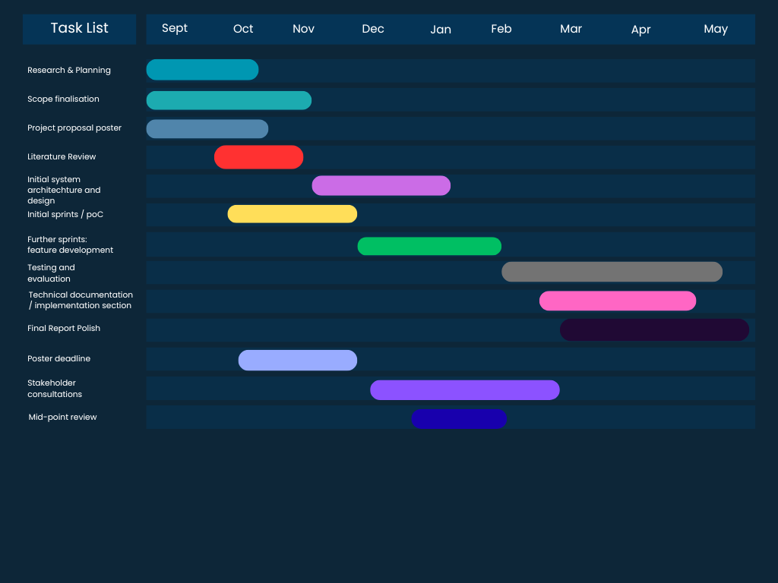

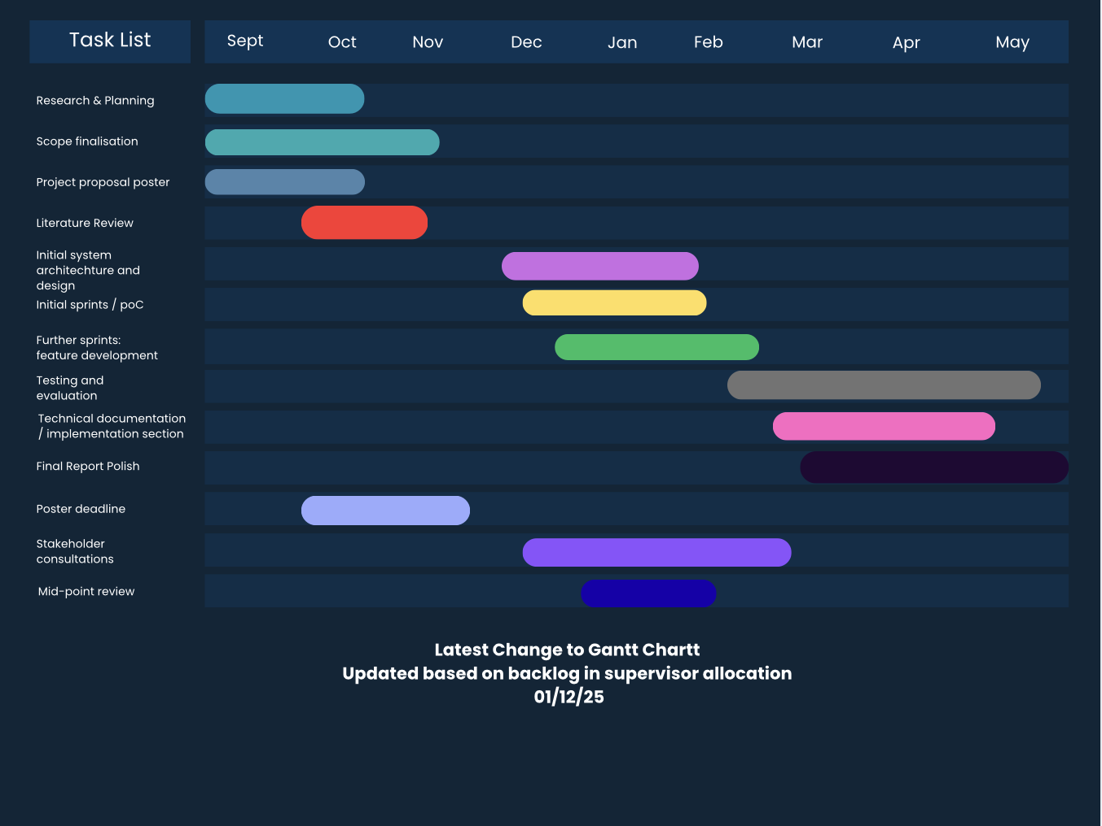

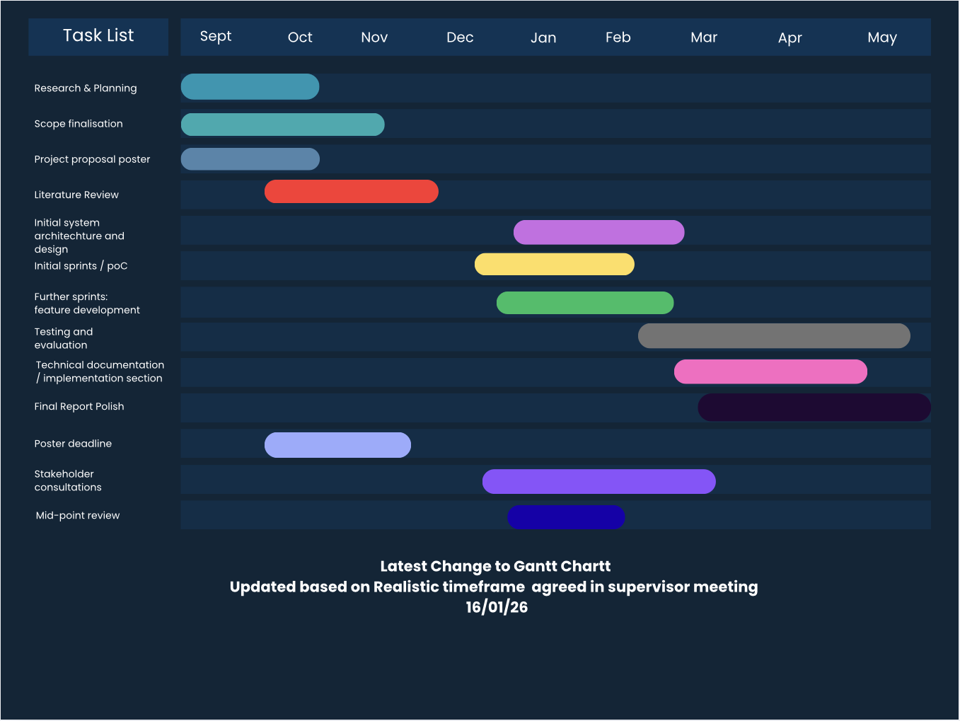

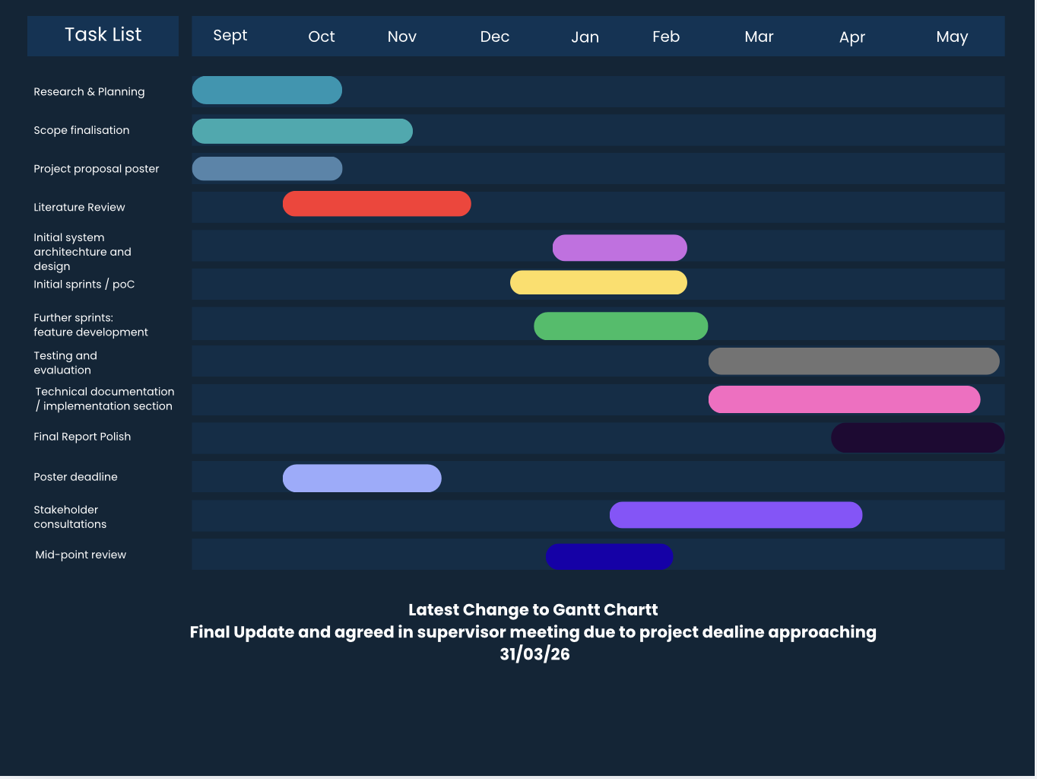

Appendix B -

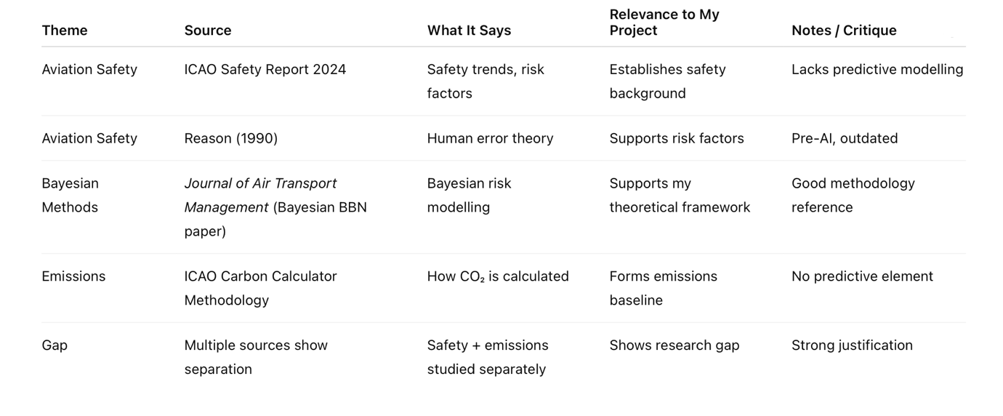

Appendix C - The researcher compiled a reading matrix to summarise key sources and their relevance to Bayesian inference in aviation.

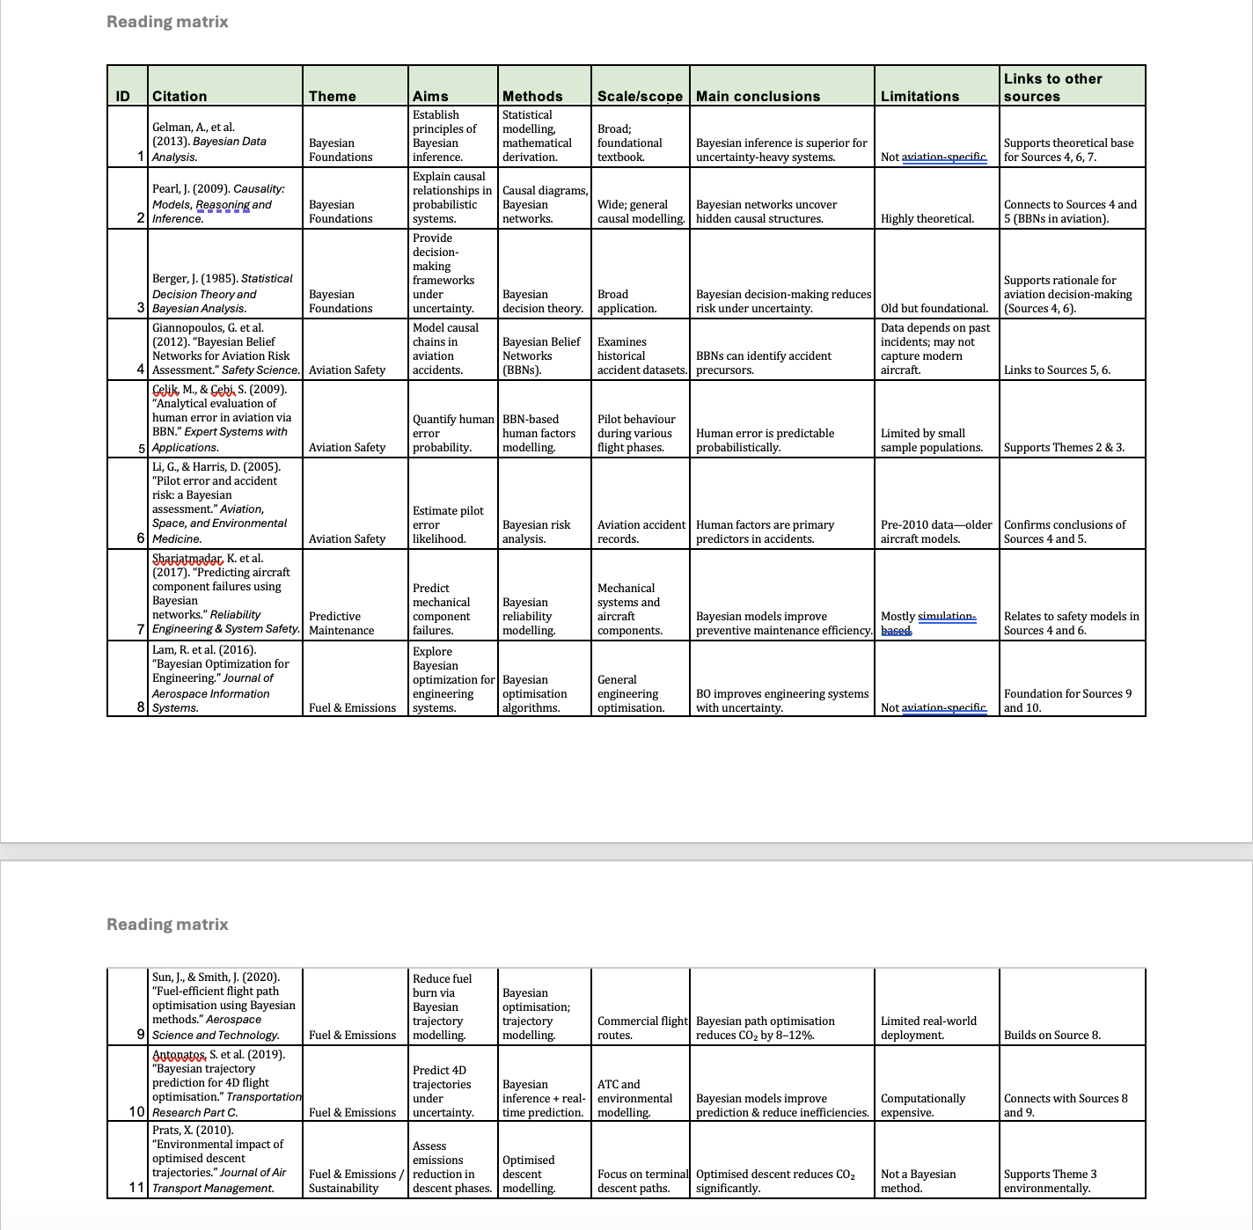

Appendix D - A synthesis matrix was created to identify themes across the literature and draw comparisons between sources.

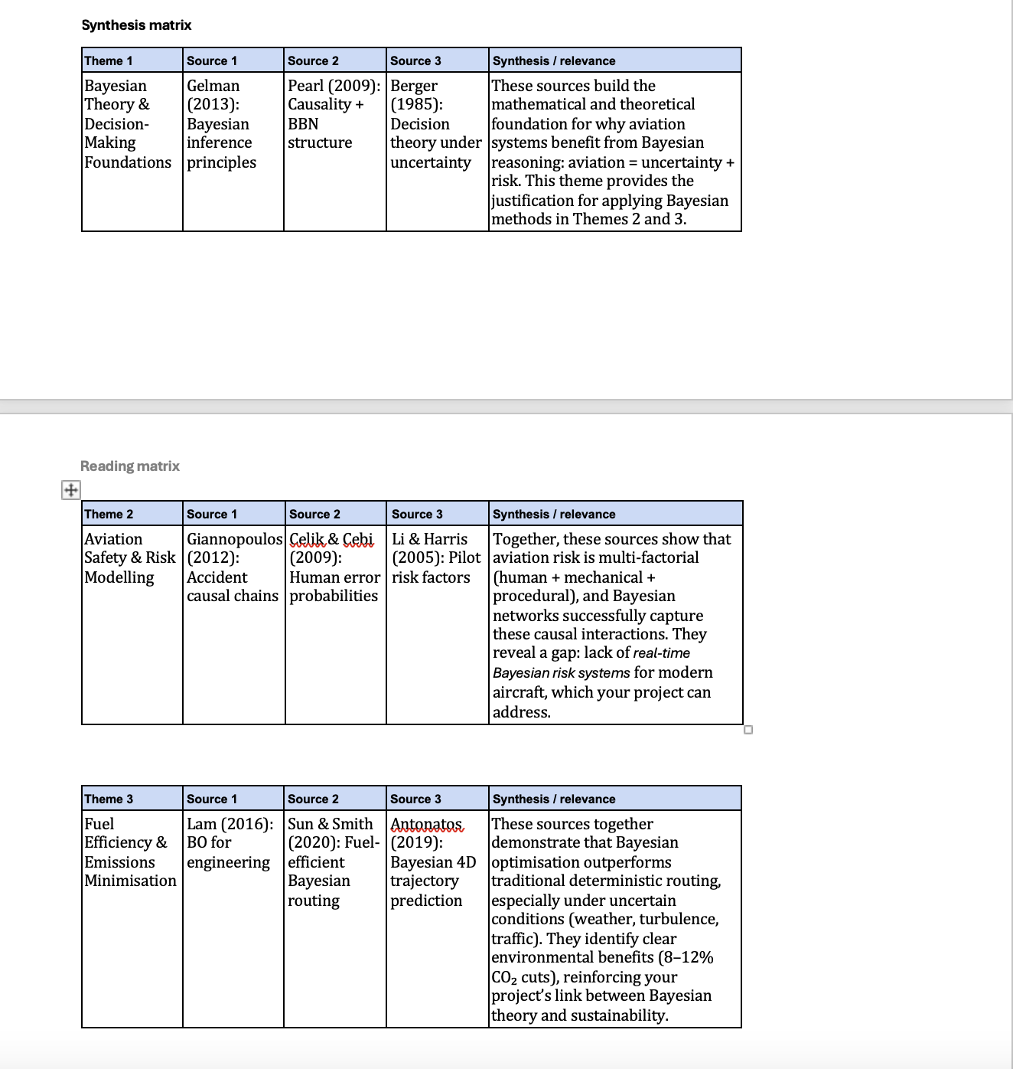

Appendix E - The literature review plan guided the thematic organisation of sources from broad context to project-specific analysis.
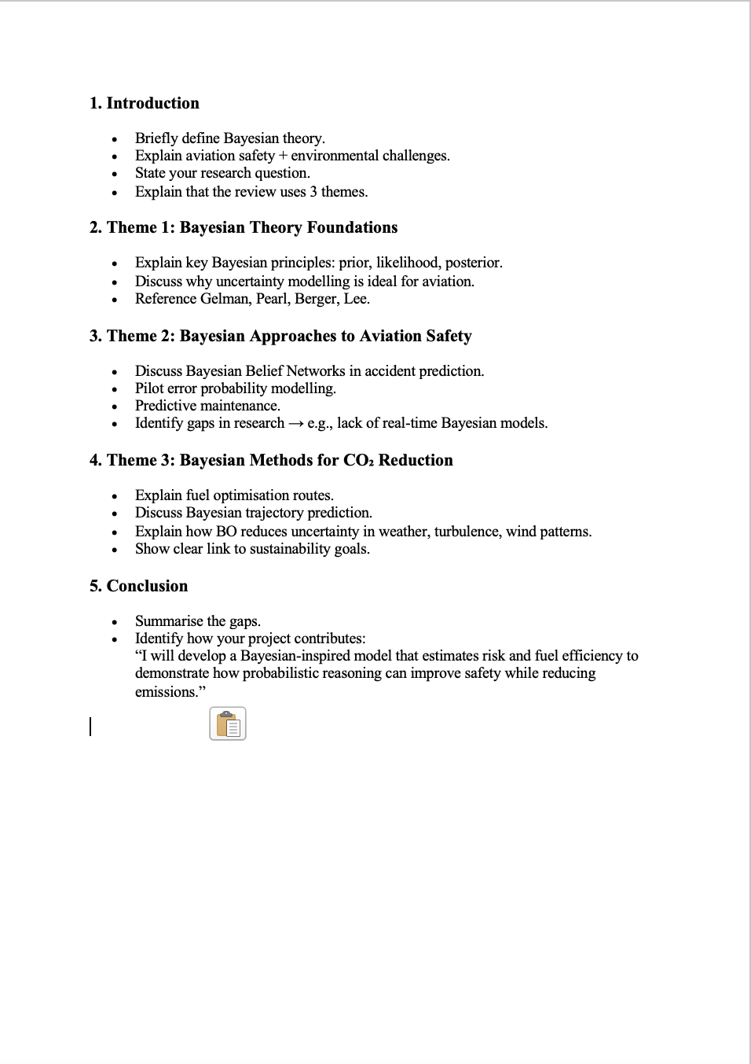

Appendix F – Project Proposal poster

Appendix G – Risk register

Risk register
Risk ID | Likelihood | Impact | Risk Description | Mitigation Strategy
R1 | Medium | High | Limited availability or poor-quality public aviation data may affect model accuracy | Use multiple public aviation datasets; conduct early data cleaning; design Bayesian models tolerant to uncertainty
R2 | Medium | Medium | Bayesian inference models may be computationally expensive | Start with simplified Bayesian models; develop proof-of-concept early using Jupyter Notebook
R3 | Medium | High | Model assumptions may not reflect real-world aviation systems accurately | Base assumptions on peer-reviewed aviation and Bayesian literature; document limitations clearly
R4 | High | Medium | Difficulty validating accident probabilities due to rarity of accidents | Use historical accident data and comparison with published studies for validation
R5 | Low | High | Ethical risk of misinterpretation of safety predictions | Clearly state academic purpose; include transparent explanation of outputs and uncertainty
R6 | Medium | Medium | Project scope may become too broad due to dual focus on safety and emissions | Maintain focused objectives; prioritise safety modelling before emissions analysis
R7 | Medium | High | Time constraints during development and evaluation | Maintain updated Gantt chart; make frequent GitHub commits to evidence progress
R8 | Low | Medium | Limited stakeholder validation opportunities | Use supervisor feedback and literature-based validation methods

Appendix H -
The solution was designed following an iterative, component-based architecture. Each module was developed and validated independently before being integrated into the unified Streamlit application. The technical plan followed five phases:

Phase | Stage | Activities | Outcome
1 | Data Collection | Obtain NTSB AviationData.csv (88k records), OpenSky flightlist CSVs (Jan–May 2019), EASA EDB v31 CO₂ factors, EASA CZIB conflict zone polygons | Raw datasets secured
2 | Pre-processing | Feature engineering: map 8 NTSB columns to 5 Bayesian features + risk class. Filter, clean, drop nulls. Validate class distribution | Clean training DataFrame
3 | Model Development | Implement UnifiedBayesianModel from scratch: log-priors, Laplace likelihoods, _posterior(), predict() returning both risk AND CO₂ in one call | Trained Bayesian model
4 | Dashboard Build | Build Streamlit multi-page app. Integrate Folium map, conflict zone overlays, AviationStack API, FuelEfficiencyModel, ScenarioHistory | Running web application
5 | Validation | Test 3 NTSB scenarios (Safe/Moderate/High). Validate routing against all 14 CZIB polygons using ray-casting. Verify fuel efficiency metrics against EASA EDB v31 | All tests pass

The system is structured as a single Python file (app.py, ~3,500 lines) with the following logical layers:
- Data Layer — NTSB CSV, OpenSky gzip files, EASA EDB (hardcoded), EASA CZIBs (hardcoded polygons)
- Model Layer — UnifiedBayesianModel (risk + emissions), FuelEfficiencyModel, AviationStack API client
- Routing Layer — Haversine distance, great-circle interpolation, ray-casting conflict detection, direction-aware waypoint builder
- Presentation Layer — Streamlit pages, Folium maps, session state, admin authentication

Appendix I -
The following table documents how raw NTSB database columns are mapped to the five Bayesian input features:

Bayesian Feature | NTSB Source Column | Mapping Logic | Values
weather | Weather.Condition | VMC → low, IMC → high, else medium | low / medium / high
maintenance | Amateur.Built + Engine.Type | Amateur=Yes → poor; Engine=NONE → fair; else → good | good / fair / poor
aircraft_age | Engine.Type | TurboJet/Fan/Shaft → new; Reciprocating → old; else → mid | new / mid / old
route_complexity | Broad.phase.of.flight | Takeoff/Landing/Approach → high; Cruise/Climb → low | low / medium / high
congestion | FAR.Description | Part 121 Air Carrier → high; Part 135 Commuter → medium | low / medium / high
risk_class (target) | Injury.Severity + Aircraft.damage | Fatal/Destroyed → High; Serious/Substantial → Medium; else → Low | Low / Medium / High

Appendix J -
The class diagram below shows all classes in the system, their attributes, methods, and relationships. Associations are described following the diagram.

«class» UnifiedBayesianModel
Attributes | Methods
+ FEATURES: dict | + __init__(df: DataFrame)
+ CLASSES: list[str] | - _train(df: DataFrame)
+ SCORE_WEIGHTS: dict | - _posterior(inputs: dict): tuple
+ CO2_OVERHEAD: dict | + predict(inputs, aircraft, distance_km): dict
+ LOW_THR: int = 30,000 | + estimate(aircraft, distance_km): tuple
+ HIGH_THR: int = 100,000 | + interpret(co2, distance_km): dict
- _P: dict (prototype likelihoods)
- log_priors: dict
- likelihoods: dict
+ trained_on_data: bool
+ n_training: int
+ risk_dist: dict

«class» FuelEfficiencyModel
Attributes | Methods
(no instance state — stateless) | + compute(ac, km, lf=0.85): dict
(reads AIRCRAFT_CATALOGUE global) | + compare_all(km, lf=0.85): dict
(1 kg jet fuel = 1.25 L)
(CO₂ factor: 3.16 kg/kg fuel)

«module» GeoUtils (module-level functions)
haversine(lat1, lon1, lat2, lon2) → int (km)
great_circle_points(lat1, lon1, lat2, lon2, n=80) → list[tuple]
avoidance_route(o_lat, o_lon, d_lat, d_lon, waypoints) → list[tuple]
_build_safe_waypoints(o_lat, o_lon, d_lat, d_lon, direct_hits, mode_key) → tuple
_point_in_poly(lat, lon, polygon) → bool
point_in_conflict_zone(lat, lon) → list[dict]
route_passes_through_zones(pts) → list[dict]
_lookup_coords(code) → tuple | None
_distance_from_airport_codes(origin, dest) → int | None

Class Relationships
- UnifiedBayesianModel ──uses──▶ AIRCRAFT_CATALOGUE (global dict) to read co2_km factor in predict()
- UnifiedBayesianModel ──uses──▶ NTSB DataFrame (passed to __init__) for training
- FuelEfficiencyModel ──uses──▶ AIRCRAFT_CATALOGUE (global dict) for seats, burn_kg_hr, speed
- page_risk() ──instantiates──▶ UnifiedBayesianModel at bootstrap, calls predict()
- page_route() ──calls──▶ GeoUtils functions, ──reads──▶ CONFLICT_ZONES list, ──reads──▶ AIRPORTS dict
- page_fuel() ──instantiates──▶ FuelEfficiencyModel at bootstrap, calls compute() and compare_all()
- lookup_flight() ──calls──▶ AviationStack API (HTTP GET), ──uses──▶ _distance_from_airport_codes()
- EmissionsModel = UnifiedBayesianModel (alias — same class serves both purposes)

Appendix K – Sequence diagram
This sequence diagram describes the complete user journey for the primary use case: a user enters a flight number, the system fetches live data, and the Unified Bayesian Model produces both a risk score and an expected CO₂ estimate in a single inference pass.

Step | Actor / Component | Action | Data Returned
1 | User → Browser | Navigates to Risk Analysis page
2 | Browser → Streamlit | Selects 'Enter a Flight Number' mode | input_mode = flight_number
3 | User → Streamlit | Types flight number, clicks Look Up Flight | flight_num = 'BA249'
4 | Streamlit → AviationStack API | HTTP GET /v1/flights?flight_iata=BA249 | API key, flight_iata param
5 | AviationStack API → Streamlit | Returns JSON flight record | {airline, origin_iata, dest_iata, aircraft_type, status, delay}
6 | Streamlit → _lookup_coords() | Resolve origin IATA → coordinates | 'LHR' → (51.47, -0.45)
7 | Streamlit → _lookup_coords() | Resolve dest IATA → coordinates | 'DOH' → (25.26, 51.61)
8 | Streamlit → haversine() | Calculate real route distance | → 5,242 km
9 | Streamlit → _iata_to_aircraft_key() | Map API aircraft code to catalogue key | '332' → 'A330-200'
10 | Streamlit → _map_status_to_congestion() | Map flight status/delay to congestion feature | delay=0 → 'low'
11 | Streamlit → session_state | Store prefill: aircraft, distance, congestion, complexity | st.session_state['flight_prefill']
12 | Browser → Streamlit | User reviews pre-filled form, clicks Run Unified Analysis | inputs dict: {weather, maintenance, age, complexity, congestion}
13 | Streamlit → UnifiedBayesianModel._posterior() | Compute log P(C|X) = log P(C) + Σ log P(xᵢ|C) for all classes | log_posteriors dict
14 | UnifiedBayesianModel → _posterior() | Exp-normalise to posterior probabilities P(Low|X), P(Med|X), P(High|X) | probabilities dict
15 | UnifiedBayesianModel → predict() | Compute risk_score = Σ P(C) × weight(C) | score: 0–100
16 | UnifiedBayesianModel → predict() | Read CO₂ factor from AIRCRAFT_CATALOGUE (EASA EDB v31) | co2_factor = 18.5 kg/km
17 | UnifiedBayesianModel → predict() | Compute CO₂_expected = Σ P(C|X) × base_CO₂ × overhead(C) | expected_co2 (kg)
18 | UnifiedBayesianModel → Streamlit | Return unified result dict: risk class, score, posteriors, base_co2, expected_co2, em_level | Result dict
19 | Streamlit → Browser | Render risk badge, emission badge, posterior bars, computation detail | HTML dashboard output
20 | Streamlit → session_state.history | Append scenario record for export | {Type, Aircraft, Distance, Risk, Score, CO₂}

Appendix L - Entity Relationship Diagram (ERD)
The ERD represents the logical data model of the system. As this is a file-based prototype rather than a database-backed application, the 'entities' correspond to the structured data objects that persist in-session or are loaded from files.

Entity | Key Attributes | Cardinality / Notes
SCENARIO (session) | scenario_id (auto), type, aircraft, distance_km, risk_class, risk_score, expected_co2 | Many per session. Written by all analysis pages. Exported as CSV.
NTSB_RECORD | n_number, event_date, injury_severity, aircraft_damage, weather_condition, engine_type, far_description, phase_of_flight, amateur_built | 88,000+ records. Read-only. Source: AviationData.csv. One record → one training sample.
TRAINING_SAMPLE (derived) | weather, maintenance, aircraft_age, route_complexity, congestion, risk_class | Derived from NTSB_RECORD by feature engineering. 1:1 mapping after cleaning.
AIRCRAFT | iata_code (PK), maker, family, seats, burn_kg_hr, cruise_speed, range_km, engines, co2_km | 28 records. Hardcoded from EASA EDB v31. Referenced by SCENARIO and FLIGHT.
AIRPORT | iata_code (PK), display_name, country, icao_code, lat, lon | 777 records. Hardcoded. Referenced by ROUTE and FLIGHT.
CONFLICT_ZONE | zone_id (PK), name, status, level, source, polygon (list of lat/lon) | 14 records. Hardcoded from EASA CZIB 2026-03-R5. Referenced by ROUTE.
OPENSKY_FLIGHT | callsign, origin_icao (FK→AIRPORT), dest_icao (FK→AIRPORT), typecode, day | Up to 60,000 records. Read from .csv.gz files. Used for route cross-reference.
FLIGHT (API) | flight_iata, airline, origin_iata (FK→AIRPORT), dest_iata (FK→AIRPORT), aircraft_type (FK→AIRCRAFT), status, dep_delay | 1 record per lookup. Fetched live from AviationStack API. Transient — not persisted.
ROUTE (computed) | origin (FK→AIRPORT), destination (FK→AIRPORT), mode_key, direct_km, adj_km, waypoints, adj_hits (FK→CONFLICT_ZONE) | Computed on demand in Route Planner. Not persisted beyond session.

Relationships
- NTSB_RECORD (1) ──derives──▶ (1) TRAINING_SAMPLE [after feature engineering]
- TRAINING_SAMPLE (many) ──trains──▶ (1) UnifiedBayesianModel
- SCENARIO (many) ──references──▶ (1) AIRCRAFT [via aircraft key]
- OPENSKY_FLIGHT (many) ──references──▶ (2) AIRPORT [origin + destination]
- FLIGHT/API (1) ──references──▶ (1) AIRCRAFT, (2) AIRPORT
- ROUTE (1) ──references──▶ (2) AIRPORT, (0..many) CONFLICT_ZONE

Appendix M- Network / System Context Diagram
The network diagram shows all external services, data sources, and system components with their communication protocols and data flows.

Component | Type | Protocol / Interface | Data Flow Description
User Browser | Client | HTTP / localhost:8501 | Sends UI interactions; receives rendered Streamlit HTML/JS
Streamlit Server (app.py) | Application Server | Python runtime / localhost | Central application. Orchestrates all models, renders UI, manages session state
NTSB AviationData.csv | Local File | pandas.read_csv() at startup | 88k+ records → feature engineering → UnifiedBayesianModel training. One-time read, cached.
OpenSky flightlist_*.csv.gz | Local File | gzip + pandas.read_csv() at startup | Up to 60k rows of ICAO flight pairs → route cross-reference. One-time read, cached.
AIRCRAFT_CATALOGUE (hardcoded) | In-Memory Dict | Python dict access | 28 aircraft variants. CO₂ factors from EASA EDB v31. Read by model + fuel pages.
CONFLICT_ZONES (hardcoded) | In-Memory List | Python list access | 14 EASA CZIB polygon dicts. Read by route planner on every route calculation.
AIRPORTS (hardcoded) | In-Memory Dict | Python dict access | 777 airports. Used by route planner for coordinate lookups and dropdowns.
AviationStack REST API | External HTTP API | HTTP GET / JSON / api.aviationstack.com | Flight lookup on user request. Returns airline, route, aircraft, delay. 100 calls/month free tier. Timeout 8s.
Folium / Leaflet.js | External Library + CDN | Python → HTML → browser CDN | Map tiles from CartoDB dark_matter CDN. Folium renders HTML string, injected via components.html()
Sketchfab CDN | External CDN | HTTPS iframe embed | 360° engine model. Embedded in Aircraft Explorer page via iframe. No auth required.
GitHub | Version Control | Git / HTTPS | All source code committed. Branching used for feature development. Evidence of professional practice.

Security & Data Flow Notes
- All data processing is local — no user data is transmitted externally except for the AviationStack flight number lookup
- The AviationStack API key is hardcoded in app.py. In a production system this would be stored as an environment variable
- The Streamlit app runs entirely on localhost — there is no public-facing server, authentication is session-based admin toggle only
- Map tiles are fetched from CartoDB CDN by the user's browser directly (not via the Python server)
- The OpenSky data is 2019 historical data — no real-time ADS-B data is consumed

Appendix N – User stories

ID | User Story | Acceptance Criteria
US-1 | As an aviation analyst, I want to input flight parameters and receive accident probability and CO₂ emission estimates so that I can make informed pre-flight operational decisions. | System returns Low/Medium/High risk class, 0–100 risk score, three posterior probabilities summing to 100%, and expected CO₂ in kg within 2 seconds of form submission.
US-2 | As an aviation analyst, I want to enter a flight number and have route details automatically populated so that I do not have to look up aircraft type and distance manually. | AviationStack API returns airline, route, aircraft type, and delay. Distance auto-calculated from IATA airport coordinates. Form pre-filled with correct values.
US-3 | As a student, I want to change individual flight parameters and see how risk and emissions respond so that I can understand the sensitivity of Bayesian outputs. | Changing any single input (e.g. weather low → high) produces a visibly different risk class, updated posterior probabilities, and a changed expected CO₂ value.
US-4 | As a student, I want to visualise how different aircraft types compare on fuel efficiency so that I can understand environmental trade-offs between aircraft families. | Fuel Efficiency page shows L/100 passenger-km bar chart for all 28 aircraft variants at a selected distance. Most efficient aircraft visually distinguishable.
US-5 | As a trainer, I want to export analysed scenarios as a CSV so that I can present results in a briefing or classroom session. | Scenario History page shows all completed analyses with aircraft, distance, risk class, score, and CO₂. Download CSV button produces a correctly formatted file.
US-6 | As any user, I want to plan a route and see it avoid active conflict zones so that I can understand how real airspace closures affect flight paths. | Route Planner (admin) shows Folium map with EASA CZIB zones drawn in red/orange. Safer mode route does not cross any red zone polygon, verified by ray-casting.

Appendix O – User Journey
1 | User opens the application at localhost:8501. Home page displays system overview, NTSB training data metrics, and module descriptions.
2 | User selects 'Risk Analysis' from the navigation bar.
3 | User selects 'Enter a Flight Number' mode. Types a flight number (e.g. QR8). Clicks Look Up Flight.
4 | System queries AviationStack API. Flight details returned: airline, origin (LHR), destination (DOH), aircraft type, status. Distance auto-calculated as 5,242 km. Route complexity set to 'low' (long-haul). Form pre-filled.
5 | User reviews auto-filled parameters. Adjusts weather severity to 'medium' to reflect current conditions. Leaves other fields as populated.
6 | User clicks Run Unified Analysis. System calls UnifiedBayesianModel.predict() — a single inference pass returning both risk posteriors and Bayesian-weighted CO₂.
7 | Dashboard displays: Risk category badge, risk score /100, posterior probability bars for Low/Medium/High, Unified Emissions Estimate (baseline CO₂ vs risk-adjusted CO₂), contextual equivalents (car years, trees), and interpretation text.
8 | User optionally expands 'View Bayesian Computation Detail' to inspect log-posterior values and CO₂ contribution per class.
9 | Scenario is automatically saved to Scenario History. User can download CSV from the History page.

Appendix P – Use Case Descriptions
Field | Description
Use Case ID | UC-01
Title | Unified Risk and Emissions Analysis
Primary Actor | Aviation Analyst / Student
Trigger | User submits flight parameters via form or flight number lookup
Precondition | Application running at localhost:8501. NTSB CSV loaded (or prototype mode active).
Main Flow | 1. User inputs parameters. 2. System calls predict(inputs, aircraft, distance_km). 3. Log-posteriors computed. 4. Risk class, score, and unified CO₂ returned. 5. Dashboard rendered.
Alternative Flow | If AviationStack API fails: user switches to manual entry. All fields editable.
Exception Flow | If API quota exhausted: _API_EXHAUSTED flag shows quota message. Manual entry always available.
Postcondition | Scenario saved to session history. Result visible in dashboard.

Field | Description
Use Case ID | UC-02
Title | Conflict Zone Route Planning
Primary Actor | Admin (authenticated) — Aviation Analyst
Trigger | Admin selects origin, destination, aircraft, route preference and clicks Plan Route
Precondition | Admin logged in. AIRPORTS dict loaded. CONFLICT_ZONES list loaded.
Main Flow | 1. Direct great-circle computed. 2. route_passes_through_zones() checks all 14 EASA CZIB polygons via ray-casting. 3. _build_safe_waypoints() selects direction-aware corridor. 4. Folium map rendered with zone overlays and avoidance route.
Alternative Flow | Shortest mode: direct route shown with conflict zone warning.
Postcondition | Map displayed. CO₂ comparison shown. Scenario saved to history.

Appendix Q – Wireframes and wireframe descriptions
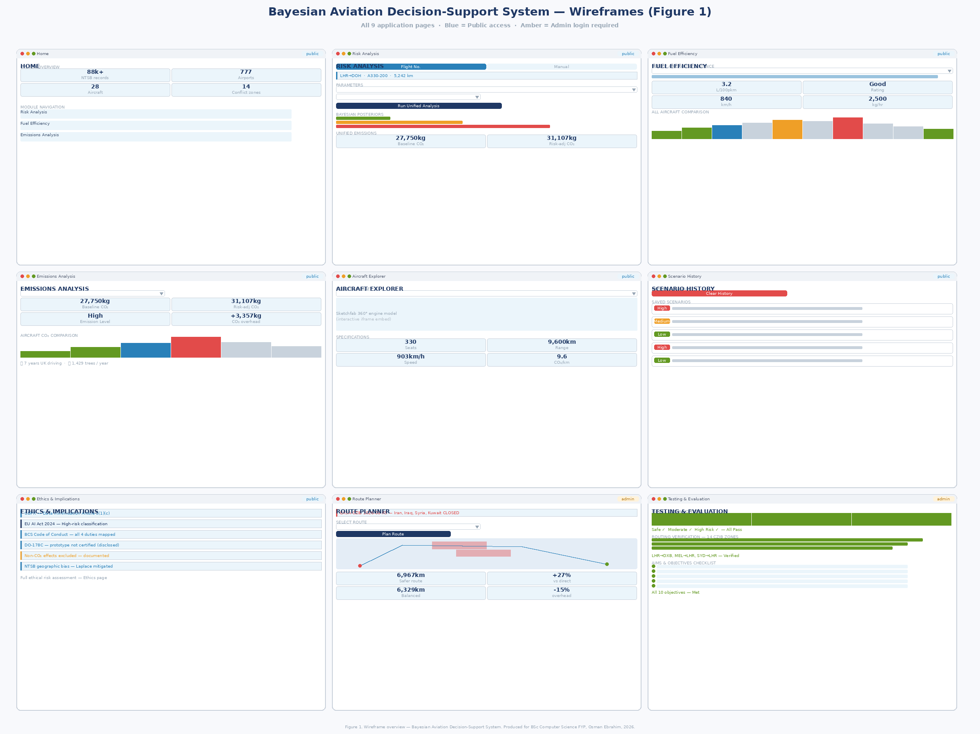

Page | Access | Key UI Elements
Home | Public | NTSB metrics (4 metric cards), OpenSky stats, module card grid (6 cards), data sources table, disclaimer
Risk Analysis | Public | Toggle: flight number / manual. Flight info card. 7-field parameter form. Run button. Posterior bars, dual risk/emissions badges, computation expander
Fuel Efficiency | Public | Aircraft selectbox, distance slider, load factor. 4 metric cards. Horizontal efficiency bar chart (all 28 aircraft). Interpretation text.
Emissions Analysis | Public | Aircraft + distance inputs. CO₂ metric cards. Emission level badge. Aircraft comparison bars. Car/tree equivalents.
Aircraft Explorer | Public | Aircraft dropdown. Sketchfab 360° iframe embed. Specification info card.
Scenario History | Public | Scenario cards (all past analyses). Download CSV button. Clear History button.
Ethics & Implications | Public | 6 ethics sections with callout boxes. Risk assessment table. BCS duty mapping table. References.
Route Planner | Admin | EASA CZIB status banner. Origin/destination dropdowns (777 airports, 200 countries). Folium map with conflict zone polygons. Route comparison metrics.
Testing & Evaluation | Admin | Scenario test results. Fuel efficiency validation. Conflict zone coverage table. Aims/objectives checklist.

Appendix R – Functional Requirements
ID | Category | Requirement | Priority
FR-01 | Model | System shall train a Naive Bayes classifier from NTSB AviationData.csv with Laplace smoothing α=1 | Must Have
FR-02 | Model | System shall compute unified CO₂ estimate from the same posteriors used for risk classification | Must Have
FR-03 | API | System shall integrate AviationStack API to pre-fill risk form from live flight number lookup | Must Have
FR-04 | Routing | System shall detect conflict zone polygon violations using ray-casting algorithm | Must Have
FR-05 | Routing | System shall generate direction-aware avoidance routes verified against all 14 EASA CZIB zones | Must Have
FR-06 | Data | System shall load and preprocess NTSB CSV, mapping 8 columns to 5 Bayesian features | Must Have
FR-07 | UI | System shall provide a public-facing multi-page Streamlit dashboard with admin authentication | Must Have
FR-08 | Data | System shall provide 777 airports across 200 countries for route planning | Should Have
FR-09 | UI | System shall export scenario history as CSV | Should Have
FR-10 | UI | System shall operate in prototype mode if NTSB CSV is unavailable | Could Have

